

51st Fighter Wing

Awards & Decorations
Preparation Guide

AUGUST 1999

I:\51FW\CCEA\CONTINUITY BOOKS \ DECORATION GUIDE

CONTENTS

Chapter Page

1 INTRODUCTION 3

2 GENERAL INFORMATION

2.1. References 4
2.2. Authorization to Sign Decorations 4

3 MECHANICS OF WRITING

3.1. Punctuation

3.1.1. Comma 5
3.1.2 Dividing Words and Paragraphs 6
3.1.3. Quotation Marks 7
3.1.4. Semicolon 7
3.1.5. Apostrophe 8

3.2. Capitalization 9
3.3. Numbers 10
3.4. Grammar 12
3.5. Spelling--words often misspelled 13

4 DECORATION PREPARATION

4.1. DECOR 6 16
4.1.1. DECOR 6 Example 17

4.2. Decoration Justification/Indorsement 20

4.3. Air Force Achievement Medal (AFAM)
4.3.1. Criteria for Submission 21
4.3.2. Format 21
4.3.3. AFAM Certificate, AF Form 2274, Example 23
CONTENTS CONTINUED

Chapter Page

4.4. Air Force Commendation Medal (AFCM)
4.4.1. Criteria for Submission 24
4.4.2. Format 24
4.4.3. Citation Example 27
4.4.4. AFCM Certificate, AF Form 2224, Example 28

4.5. Meritorious Service Medal (MSM)
4.5.1. Criteria for Submission 29
4.5.2. Format 29
4.5.3. MSM Certificate, AF Form 2228, Example 31

  - Aerial Achievement Medal
    - Criteria for Submission 32
    - Format 32
    - Citation Example 34
    - AAM Certificate, AF Form 2275, Example 35

4.7. Legion of Merit (LOM)
4.7.1. Criteria for Submission 36
4.7.2. Format 36
4.7.3. Justification Example
4.7.3.1. Narrative Format 39
4.7.3.2. Bullet Format 40
4.7.4. Citation Example 41

5 HELPFUL HINTS

5.1. Helpful Hints 42
5.2. Checklist 43
CHAPTER 1

INTRODUCTION

Decorations are a very important part of everyone’s career. They are awards in recognition of achievements and services, which are clearly outstanding and unmistakably exceptional when, compared to similar achievements and accomplishments of personnel of like rank and responsibility. Successfully carrying out of a predesignated tasks or functions is not a valid basis for any award. Decorations provide permanent, long term record of a person’s accomplishments above and beyond the “call of duty.” They play an important role in documenting information which may be used to make decisions affecting an individual’s career. As such, I challenge supervisors to focus their efforts on producing an administratively accurate and high quality product.

To assist you in this process, this guide has been prepared to help you process recommendations for decoration submissions for your squadrons. It is our responsibility as program managers, whether at the MPF, squadron, or group level, to ensure all decorations submitted to me, and HQ PACAF comply with regulations. Decorations should be submitted on time, to serve the purpose for which they were designed.

Our people are our most important resource. Take the time to recognize outstanding accomplishments and treat each decoration as if it were your own.

//SIGNED//
ROBERT R. DIERKER
Brigadier General, USAF
Commander, 51st Fighter Wing
CHAPTER 2

GENERAL INFORMATION

2.1. References
The following are additional references to assist you in preparing decorations:

AFI 36-2803 The Air Force Awards and Decorations Program

AFH 33-337 The Tongue and Quill

2.2. Authorization to Sign Decorations
2.2.1. Anyone, other than the person recommended, who has knowledge of the act, achievement, or service believed to warrant award of a decoration may initiate a recommendation for an award. However, unless otherwise authorized by HQ USAF because of operational conditions, recommendations must be forwarded through the recipient’s normal chain of command with each commander in the chain indicating concurrence.

2.2.2. The 51 FW/CC is approval authority for all Meritorious Service Medals, Aerial Achievement Medals, and Air Force Commendation Medals awarded to personnel assigned to the wing. The 51 FW/CV is the approval authority for Air Force Achievement Medals for personnel assigned to the wing staff.

2.2.2.1. The 51 SPTG/CC, 51 LG/CC, 51 OG/CC, and 51 MG/CC, when in the grade of colonel or above, approves Air Force Achievement Medals for all conditions on their respective unit personnel.
CHAPTER 3

MECHANICS OF WRITING

3.1. Punctuation

3.1.1. Comma
3.1.1.1. Use with titles following personal names. (Jr. and Sr. are set off by commas; II and III are not).

Examples:

Major Richard P. Price, Jr., distinguished himself by...

Airman Michael F. Jackson II distinguished himself by...

3.1.1.2. To separate three or more words in a series, including the word before the final and, or, or nor.

Example:

He installed, configured, and operationally tested a backup system during Exercise ULCHI FOCUS LENS 1998.

3.1.1.3. To set off figures in groups of four or more digits.

Example:

Sergeant Greenleaf saved the Air Force 200,000 dollars through his diligence in the reconstruction of a runway, laying over 4,500 tons of asphalt.

3.1.1.4. To set off interrupting words, phrases, or clauses when breaking the flow of the sentence.

Examples:

Sergeant Sunshine assisted in supervising 15 mechanics, under field conditions, performing repairs to 100 pieces of construction equipment.

She monitored the status of aircraft and equipment for generated forces, required and anticipated, in support of Headquarters Pacific Air Forces operation plan taskings.

3.1.1.5. To set off explanatory dates, addresses, place names, and words identifying a title or position following a person's name.

Examples:

He was praised by the Commander, Headquarters Pacific Air Forces, for his creative support concept.

3.1.1.6. When writing the name of a military installation, a comma must follow the name of the base and the country.

Example:

Sergeant Flower’s unsurpassed engine system knowledge and experience were once again displayed during a deployment to Suwon Air Base, Republic of Korea, in May 1998, where he led a team of technicians in the replacement of 4 aircraft engines and the repair of 26 other engine system anomalies.

3.1.1.7. To set off phrases introduced by as well as, plus, along with, or coupled with when it falls between a subject and verb.

Examples:

Sergeant Popeseed’s superior performance managing a nearly 2 million dollar annual combat training program, coupled with close military-to-military relations with host-nation armed forces, provided the majority of live-fly deployment and training opportunities within the Pacific Air Forces Command.

Lieutenant Lazy’s superior performance managing a nearly 2 million dollar annual combat training program, as well as his close military-to-military relations with host-nation armed forces, ensured successful training scenarios were provided within the Pacific Air Forces Command.

3.1.2 Dividing Words and Paragraphs
      - Never further divide words that contain a hyphen—break these words at the built-in hyphen.

Example: self-/control, not self-con/trol

      - When necessary to divide a name, carry over only the surname (never separate a first name from a middle initial, an initial from a middle name or initials used in place of a first name).

Examples: Sophie B./Hawkins; T.R./Taylor, Jr.

      - A person’s rank or title should be on the same line with first name or initials.

Example: Captain Paula A./Cole not Captain/Paula A. Cole

      - When it’s necessary to divide a date, separate the year from month—do not split the month from the day.

Example: 7 January/2000 not 7/January 2000

3.1.2.5. When it’s necessary to divide the numeric portion of the wing, group, or squadron do not separate the numeric portion from the designation.

Examples: 51st Fighter/Wing not 51st/Fighter Wing
25th Fighter/Squadron not 25th/Fighter Squadron

3.1.3. Quotation Marks
3.1.3.1. Use to enclose the exact words of a speaker or writer, to enclose slogans or mottoes, and to enclose words or phrases used to indicate humor, slang, irony, or poor grammar. (Note: When using quotation marks with other punctuation, the comma and period are always placed inside the closing quotation marks; the semicolon is always placed outside the closing quotation points; the dash, exclamation mark, and question mark are placed according to the structure of the sentence.)

Examples:

Sergeant Happiness’ superior leadership during a combat evaluation readiness exercise led to her selection as an “Outstanding Performer” for unmatched command and control as a Fire Team Leader.

Major Pain’s efforts were praised by the United States Army Detachment Commander as the “best joint combat planning exercise seen to date.”

3.1.4. Semicolon
3.1.4.1. To separate independent clauses not connected by a coordinating conjunction (and, but, for, or, nor, so), and in statements too closely related in meaning to be written as separate sentences.

Examples:

Our Commander directed insertion of air traffic controllers into Japan; Captain Kmart led the effort by coordinating the deployment of Federal Aviation Administration flight inspectors.

His planning efforts took months; however, the project was completed ahead of schedule.

3.1.4.2. Before transitional words and phrases, such as however, therefore, hence, furthermore, as a result, consequently, moreover, nevertheless, and for example, when connecting two complete but related thoughts and a coordinating conjunction is not used. These words and phrases are followed by a comma.

Example:

He planned 13 exercises in fiscal year 1998 with a 3 million dollar budget; as a result, Seventh Air Force forces received exceptional training.

3.1.5. Apostrophe
3.1.5.1. To create possessive forms of certain nouns and abbreviations (do not use abbreviations in the citation) used as nouns. Add " 's" to nouns that do not end with an "s". Add only the apostrophe to nouns that end in "s" or with an "s" sound, and to the words appearance, righteousness, and conscience.

Examples:

Sergeant Dawson’s leadership and guidance in the fuels control center was instrumental in the
51st Fighter Wing receiving an “Excellent” rating for the aircraft generation phase of the November 1998 Headquarters Pacific Air Forces Outstanding Enlisted Health Services Management Award.

Airman Jones’ outstanding professional skill and leadership contributed immeasurably in establishing the newly formed air operations center.

3.1.5.2. Do not use an apostrophe when forming possessive pronouns; e.g., ours, theirs, its, hers, and yours.

Example:

As comptroller, he identified the need for the headquarters to advocate its own funding.

      - When discussing standards you should use s’, when discussing awards you should use s’, however, when you are discussing inspections you just use s.

Example:

During the 1998 Headquarters Pacific Air Forces Initial Response Readiness Inspection,
Sergeant Doolittle performed the last look pre-flight inspections on 15 A/OA-10 aircraft prior to being released for inspection, which significantly contributed to the “Excellent” rating for aircraft generation flight.

3.2. Capitalization
3.2.1. Capitalize titles when used with a proper name or in place of a specific proper name but not when used in a general sense.

Examples:

Our Commander personally commended her efforts during the 1998 Seventh Air Force Commanders’ Conference.

Several wing commanders made positive comments regarding Major Bright’s outstanding performance during the 1998 Seventh Air Force Commanders’ Conference.

3.2.2. Capitalize military rank when used with a proper name but not when it stands alone.

Example:

During this period, Sergeant Donald Duck, one of my best technical sergeants, was singled out for his contributions to the mission by the 1997 Headquarters Pacific Air Forces Quality Air Force Assessment team.

3.2.3. Capitalize the names of programs when used as proper nouns but not when used in a general sense.

Examples:

During his tenure, he served as the 51st Logistics Group’s Awards and Decorations Program Monitor.

During her tenure, she was in charge of the training and awards programs.

Major Slimfast aggressively ran the Seventh Air Force Weight Management Program.

The squadron’s outstanding success during the April 1998 Headquarters Pacific Air Forces Readiness Inspection is a direct result of Airman Soandso’s management of the electronic combat program.

3.2.4. Capitalize academic degrees when the complete title of the degree is given but not when they are used as general terms of classification.

Examples:

Always striving to better herself, Lieutenant Einstein earned enough credit hours and was awarded a Master of Science Degree in Nuclear Physics.

Always striving to better himself, Airman Bloomers completed nine semester credits towards an associate’s degree.

3.2.5. Capitalize nouns only when used in the specific sense.

Examples:

Thanks to Major Pain’s efforts, our Quality Air Force Assessment was a success.

Lieutenant Wrong was very successful at coordinating with subordinate units and numbered air forces on pain tolerance research.

For her outstanding leadership abilities, Captain Right was chosen as the squadron’s candidate for Squadron Officer School.

3.2.6. Capitalizing names of operations and exercises.

Examples:

His superior pre-exercise planning resulted in 100 percent accomplishment of Exercises ULCHI FOCUS LENS, and FOUL EAGLE training objectives.

She ensured a high level of readiness for unit personnel and mobility during Operation PROVIDE COMFORT.

3.3. Numbers
3.3.1. The following categories are almost always expressed in figures, unless used in high-level executive correspondence (the citation of a decoration is considered high-level executive correspondence).

Examples:

Money: $20,000 widget (“$” must be written out on the citation: 20,000 dollar widget)
Measurements: 110 meters long
Age: 12-year-old aircraft
Dates: 5 June 1994
Dimensions: a tent 4 by 5 meters
Sizes: size 6 combat boots; a 15- by 30-foot room
Percentages: a 15 percent discount

3.3.2. Numbers zero through nine should be expressed in words. There are a few exceptions (see paragraph 3.3.3. below).

Examples:

Our unit consists of two wings, four squadrons, and one detachment.

During Exercise ULCHI FOCUS LENS, we provided five civilians, nine officers, and eight enlisted personnel.

3.3.3. Series

3.3.3.1. A series of numbers with one or more numbers 10 or higher are expressed in numbers (except for the first word of the sentence, if it happens to be a number, then it is always spelled out).

Examples:

The numbered air force consisted of 10 wings, 5 direct reporting units, and 1 detachment.

Sergeant Knight drafted procedures and led a crew of 6 in completing an urgent onetime inspection of all 26 F-16 aircraft main engine feed shut-off valves for inadvertent closure.

3.3.3.2. Numbers in a series with all numbers nine or less are always expressed as words.

Examples:

As a part of her daily duties, she directly supervised two officers, one civilian, and five noncommissioned officers.

The squadron provided five officer, nine civilian, and three enlisted personnel for Exercise ULCHI FOCUS LENS and Operation PROVIDE COMFORT

3.3.4. Numbers expressed in figures are made plural by adding "s" alone.

Examples:

The local area network team brought Seventh Air Force into the 1990s in computer technology.

Due to her outstanding efforts, all four A-10s were successfully deployed to the area of responsibility.

3.3.5. Spell out numbers that introduce sentences. A spelled out number should not be repeated in figures.

Example:

Twenty-nine personnel deployed in support of Exercise TEAM SPIRIT.

3.3.6. For typographic appearance and easy grasp of large numbers beginning with million, use words to indicate the amount rather than 0s (unless used with a related number, see paragraph 3.4.6. above).

Examples:

$12 million budget (“$” must be written out on the citation: 12 million dollar budget)

$2.7 trillion equipment account (“$” must be written out on the citation: 2.7 trillion dollar equipment account)

$300,000 savings (not $300 thousand) (“$” must be written out on the citation: 300,000 dollar savings)

3.3.7. Use figures to designate units up to and including wings.

Examples: 51st Fighter Wing
51st Medical Group
Seventh Air Force

3.4. Grammar
3.4.1. The tense of verbs must agree throughout the sentence.

Examples:

Sergeant Red serves as technical advisor and assists in the management of new equipment acquisitions.

Airman White deployed in support of Exercise ULCHI FOCUS LENS and displayed outstanding knowledge and ability in every aspect of vehicle maintenance.

3.4.2. "And" missing in a series. When three or more items are listed in a series, the last item is preceded by and, or, or nor.

Examples:

Major Blue is an excellent officer, strong pilot, and future leader. (correct)

Major Green is an excellent officer, strong pilot, future leader. (incorrect)

3.4.3. Words often confused:

accept (to receive, agree to)
except (to leave out)

affect (to influence)
effect (to bring about)

precede (to go before in rank or time)
proceed (to move forward, advance)

raise (to lift, elevate)
rise (to go up, get up)

ensure (to make certain)
insure (to cover with insurance)

there (at or in that place)
their (used to indicate possession)

set up (verb) (to erect, build up, construct, establish)
setup (noun) (the way in which something is arranged)

inbrief/outbrief (noun) (a talk giving instructions or information)
in-brief/out-brief (verb) (to give information before or after an event or issue)

drawdown (noun) (a decreased size)
draw down (verb) (to expend or deplete)

site (noun) (position or place)
cite (verb) (to quote)
sight (verb) (to see or inspect)

advice (noun) (a view or opinion)
advise (verb) (to counsel or inform)

lead (verb) (to guide)
led (verb) (guided) (past tense of lead)
lead (noun) (a metallic element)

3.5. Spelling--words often misspelled

accommodate
aircrew
airfield
Air Force-wide
airspace
air strike
air-to-air
air-to-ground
airworthiness
antiaircraft
antijam
antistatic
austere
battle staff
backup (support)
back up (hold back)
baseline
base-wide
benchstock
bimonthly
bona fide
brilliant
build-up
build up
camouflage
“can-do” attitude
cavalry
changeover
checklist
Class A mishap
cleanup (act of cleaning)
clean up (to make a profit)
close out
closeout
combat oriented
combat-oriented (as modifier)
collocated
Colombia
commitment
consistently
consummate
contemporaries
cookout
cornerstone
cost-efffective
counterair
counterdrug
coworker
crew member
cross connects
cross talk
crosstell
cutover
data base or database
day-to-day
decrypt
desktop
discipline
disseminate
downgrade
download
downtime
downtown
ensure
en route
error-free
esprit de corps
evenhanded
excel
expediter
familiar
firsthand
first-rate
flier
flight line
follow-on
follow up (related)
follow-up (adj) (relating to)
free fall
fund-raiser
goodwill
ground-to-air
groundwork
handpicked
hands-down
hands-on
hangar
hardworking
Headquarters Pacific Air Forces
head off
high-level
higher-up
impeccable
inbrief
in-depth
indorse
in-flight
in-house
in-processing
in-residence
inter-network
interswitching
intra-network
intraservice
know-how
land line
large-scale
lauded/laudable
liaison
lieutenant
lifesaver
long haul
long-range
long-standing
long-term
man-days
maintenance
man-hours
microcomputer
midair
minicomputer
mission-critical
mountaintop
multifunction
multiline
multimillion
multinational
multiservice
multitalented
nationwide
night vision goggles
nonaccountable
nonappropriated
noncombatant
noncommissioned
nonconcur
nonsecure
nonswitching
numbered air forces
occurred
off-base
off-duty
off-line
ongoing
on-hand
on-line
on schedule
on-site
on target
on time
on track
onetime (adj/adv)
ordnance
out-of-cycle
out-of-date
out-processing
overrun
overtime
overworked
pamphlet
paralleled
peacetime
peninsula-wide
postflight
pre-flight
procured
received
reall time
real world
reconfigure
re-create (to creat again)
recreate (to lounge/refresh)
relocations
Republic of Korea
reroute
rouse
reutilize
revamp
sandbag
second-to-none
self-help
self-starter
semiannual
separate
setup (noun)
set up (adj)
Seventh Air Force
short-notice
short-tour
shutdown
shut down
similar
single-handed (ly)
single line
stand-alone
standby (ready for immediate action)
stand by (to be ready to act)
state-of-the-art
step-by-step
straightforward
surface-to-air
takeoff
tangible
tenfold
time-sensitive
top-notch
troubleshoot
turnaround
turn in (hand over)
turn-in (something that’s turned in)
twofold
under budge
unequaled
update
upkeep
upload
uptime
up-to-date
warfighting
war reserve materiel
wartime
work center
work force
workload
work sheet
worldwide

CHAPTER 4

DECORATION PREPARATION

4.1. Recommendation for decoration printout (RDP) or DECOR 6--the RDP should either be typed or printed in black or blue ink.

1A. Enter the type of decoration--may be abbreviated.

1B. Be sure to include the appropriate oak leaf cluster, basic or n/a.

1C. Enter appropriate dates using information on item 5 of the DECOR 6. Do not overlap with inclusive dates from a previous decoration (refer to item 6 below).

1D. Circle as appropriate.

1E. Circle as appropriate.

1F. Enter specific date for presentation or n/a. If decoration is for separation or retirement, a date must be provided.

1G. Should already be on DECOR 6. If not, fill in correct information.

1H. Must have forwarding address if retiring or separating.

2. Correct any erroneous information. If not applicable, enter “NC.”

3. If not applicable, enter n/a.

4. Circle yes or no. If yes, follow instructions on DECOR 6.

5. Use information to complete citation, justification, and memorandum. If incorrect, update DECOR 6 neatly.

6. Use data to ensure no overlapping of decorations. If member received a previous medal for outstanding achievement during time frame of this decoration, ensure a copy of citation is enclosed.

7. Self-explanatory.

8. If decoration is not being recommended, then supervisor and commander need to sign DECOR 6.

4.1.1. DECOR 6 Example

(Bold/underlined items need to be filled in by the units.)

PERSONAL DATA - PRIVACY ACT OF 1974

SUSPENSE: AUTOMATICALLY PROVIDED BY COMPUTER BASED ON RET, PCS, DATE ETC.)

51ST SUPPORT GROUP
OSAN AFB

REPLY TO
ATTN OF: CAREER ENHANCEMENTS

SUBJECT: RECOMMENDATION FOR DECORATION -
MSGT WATERMELON JASON T. - FR777-21-0030

TO:
ATTN: CAPT STRAWBERRY DARREL M.

IF YOU SUBMIT A DECORATION RECOMMENDATION ON MSGT SQUIRES JONATHAN B, RETURN THIS FORM, THE CITATION AND THE NARRATIVE BY 1 JUL 99. IF YOU DO NOT PLAN TO RECOMMEND A DECORATION, PLEASE COMPLETE ITEM 8, OBTAIN YOUR COMMANDER’S INDORSEMENT AND RETURN THIS FORM TO US BY 1 JUN 99. IF YOU NEED ASSISTANCE, PLEASE REFER TO AFI 36-2803 OR CONTACT THE MPF CAREER ENHANCEMENTS AWARDS & DECS EXT 784-4456

1ST IND, ___________
DATE
TO: CAREER ENHANCEMENTS

1. I RECOMMEND AWARD OF:

A. DECORATION: MERITORIOUS SERVICE MEDAL B. CLUSTER: 2 OLC

C. INCLUSIVE DATES: 1 SEP 98 to 31 AUG 99

D. HEROISM, OUTSTANDING ACHIEVEMENT, MERITORIOUS SERVICE
(CIRCLE AS APPROPRIATE)

E. RET, SEP, PCS, PCA, EXT TOUR, POSTHUMOUS, ACH, HEROISM (CIRCLE AS APPROPRIATE)

F. IF APPROVED, PRESENTATION DATE DESIRED: 15 AUG 99

G. IF APPROVED, FORWARD AWARD ELEMENT TO: (INFO SHOULD ALREADY BE ENTERED. IF NOT, FILL IN CORRECT INFORMATION)

H. NEXT DUTY ASSIGNMENT OR FUTURE ADDRESS (RET OR SEP):
(IF MEMBER IS RETIRING OR SEPARATING ENSURE FORWARDING ADDRESS IS ENTERED)

2. UNIT, STATION OF ASSIGNMENT AND GRADE AT TIME OF ACT, ACHIEVEMENT OR SERVICE (IF ITEM A, B OR C IS DIFFERENT, CORRECT IN ITEM D, E AND F):

A. 51 MISSION SUPPORT SQ/ D. CHANGE IF APPLICABLE OR NC
OPORFDST
B. OSAN AFB SKORE E. CHANGE IF APPLICABLE OR NC
C. MSGT F. CHANGE IF APPLICABLE OR NC

3. IF POSTHUMOUS, OR RECOMMENDEE IS MISSING IN ACTION OR PRISONER OF WAR, GIVE NAME, RELATION AND ADDRESS OF NEXT OF KIN:

(FILL IN INFO IF APPLICABLE OR N/A)

4. ARE OTHERS BEING RECOMMENDED FOR SAME ACT/SERVICE? YES/NO IF YES, ATTACH OTHER RECOMMENDATIONS TO THIS PACKAGE. EXPLAIN ANY DELAYS, DATE RECOMMENDATION WILL BE FORWARDED AND IDENTIFY OTHERS BY GRADE, NAME, SSN, PRESENT ORGANIZATION, STATION AND DECORATION RECOMMENDED. (CIRCLE EITHER YES OR NO)

5. CURRENT DUTY TITLE: NCOIC, PERSONNEL EMPLOYMENT
DATE OF CURRENT ASGMT: DAFSC:
UNIT OF ASSIGNMENT:
INSTALLATION OF ASGMT:
EFF DATE OF PROMOTION:
DATE ARRIVED STATION: 9 JUNE 1998 (USE FOR INCLUSIVE DATES)
PROJ DEPARTURE DATE: 7 JUNE 1999 (USE FOR INCLUSIVE DATES) RNLTD:
DATE OF SEPARATION: USE FOR INCLUSIVE DATES TAFMSD:
RET-SEP-EFF-DATE-PROJ: USE FOR INCLUSIVE DATES (when ret/sep) PAY DT:
COMPONENT: REGULAR UIF:
EPR DATA:

6. DECORATION HISTORY

CLOSING ISSUING ORDER ORDER DEC
DECORATION NUMBER DATE HQS NUMBER DATE COND

CHECK THIS AREA AND ENSURE INCLUSIVE DATES OF DECORATION DO NOT OVERLAP WITH ANY OTHER DECORATION, EXCEPT IF GIVEN FOR OUTSTANDING ACHIEVEMENT. IF THERE IS AN OUTSTANDING ACHIEVEMENT AWARD DURING THE INCLUSIVE DATES, A COPY OF THE CITATION MUST BE INCLUDED IN THE PACKAGE.

7. BY VIRTUE OF SIGNING THE ATTACHED NARRATIVE/JUSTIFICATION, I CERTIFY THE MEMBER’S SERVICE DURING THE PERIOD OF THIS RECOMMENDATION HAS BEEN HONORABLE AND THE ATTACHED CITATION IS UNCLASSIFIED. NO PREVIOUS AWARD HAS BEEN MADE TO MEMBER FOR THE ACT, ACHIEVEMENT OR SERVICE DESCRIBED.

ATCH
1. NARRATIVE
2. CITATION

8. I DO/DO NOT RECOMMEND THIS INDIVIDUAL FOR A DECORATION.

_______________________________ ________________________________
SUPERVISOR/DATE COMMANDER/DATE

4.2. Decoration Justification/Indorsement
All decorations must include a 51 FW Form 121, Decoration Justification/Indorsement with the appropriate supervisor/squadron commander or staff agency chief/and group commanders’ signature. This form lets the 51 FW/CC know that the squadron commanders and group commanders have coordinated, and have possible additional comments. It is also used for addition information, if an EPR/OPR has been closed out for 90 days or more.

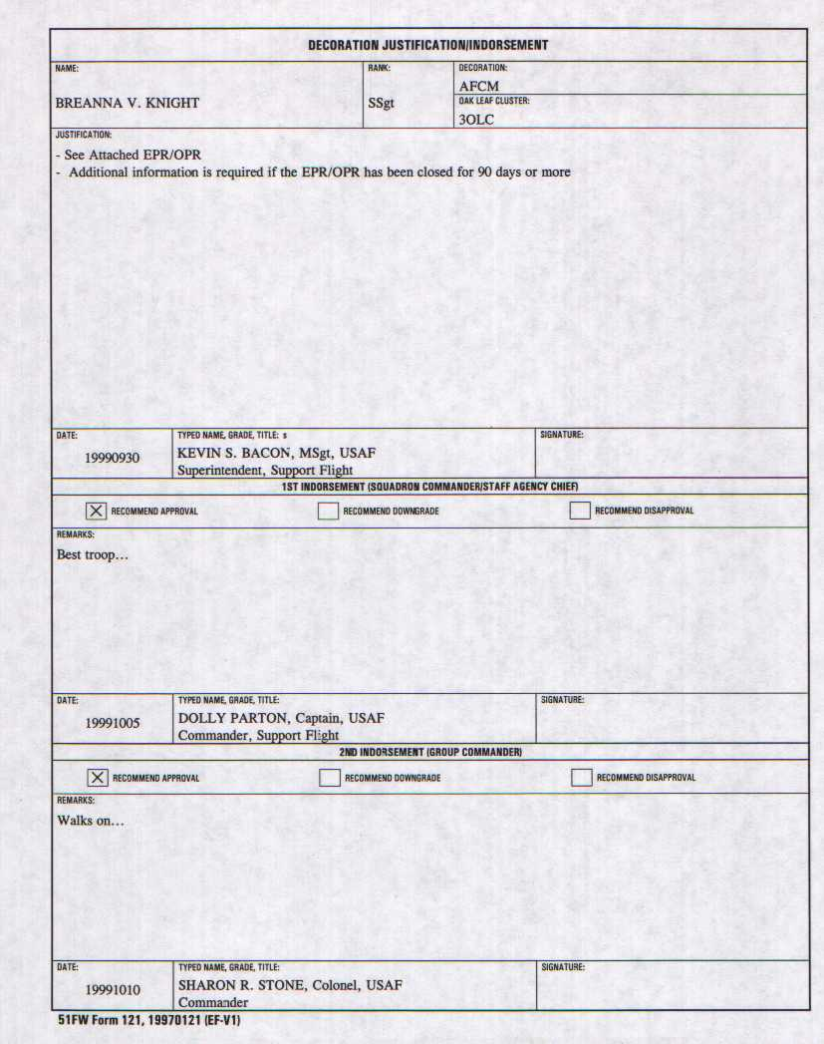

4.3. Air Force Achievement Medal (AFAM)

4.3.1. Criteria for Submission
4.3.1.1. Awarded for meritorious service or outstanding achievement, or acts of courage that does not meet the requirements of the Air Force Commendation Medal.

4.3.1.2. Will not be given for retirement or aerial achievement.

4.3.1.3. Do not award more than one AFAM during a 1-year period except under extraordinary circumstances.

4.3.1.4. Place emphasis on award to junior officers and airmen whose achievements and service meet the standards.

4.3.2. Format
4.3.2.1. The AF Form 2274, Air Force Achievement Medal Certificate, DECOR 6, EPR/OPR, and 51 FW Form 121, Decoration Justification/Indorsement are required in all packages.

4.3.2.2. Font: Times New Roman, 12 point. All print type throughout the certificate must be the same.

4.3.2.3. Center horizontally and vertically the following lines:

4.3.2.3.1. Number of oak leaf clusters (in all capital letters)

4.3.2.3.2. Rank and name (in all capital letters)

4.3.2.3.3. Outstanding achievement or meritorious service (in all capital letters)

4.3.2.3.4. Date line (in all capital letters). Dates are always written as either single or double digits. The dates must be computer generated do not use a typewriter.

Correct: 27 JUNE 1999 TO 8 JUNE 2000
Incorrect: 27 JUNE 1999 TO 08 JUNE 2000

4.3.2.4. Margins: left and right margins 1 inch, fully justified

4.3.2.5. Opening sentences
4.3.2.5.1. Meritorious Service (PCS, outstanding achievement)

Senior Airman Mary J. Blige distinguished herself by meritorious service as Airfield Management Journeyman, Airfield Operations Flight, 51st Operations Support Squadron, 51st Operations Group, 51st Fighter Wing, Osan Air Base, Republic of Korea.

OR

Senior Airman Mary J. Blige distinguished herself by meritorious service while assigned to 51st Operations Support Squadron, 51st Operations Group, 51st Fighter Wing, Osan Air Base, Republic of Korea.

4.3.2.5.2. Outstanding achievement

Senior Airman Mary J. Blige distinguished herself by outstanding achievement (at or near)

4.3.2.6. Closing sentences (The closing sentence is optional, but if used, limit to one sentence that personalizes the summation.)

4.3.2.6.1. PCS

The distinctive accomplishments of Airman Blige reflect credit upon herself and the United States Air Force.

4.3.2.6.2. Separation

The distinctive accomplishments of Airman Blige while serving her country reflect credit upon herself and the United States Air Force.

4.3.2.7. Directly under line on left side of certificate, enter 51st Fighter Wing Vice Commander’s first name, middle initial, and last name (in all upper case), enter rank (spelled out, upper/lower case), and USAF. On second line, enter Vice Commander, 51st Fighter Wing (upper/lower case).
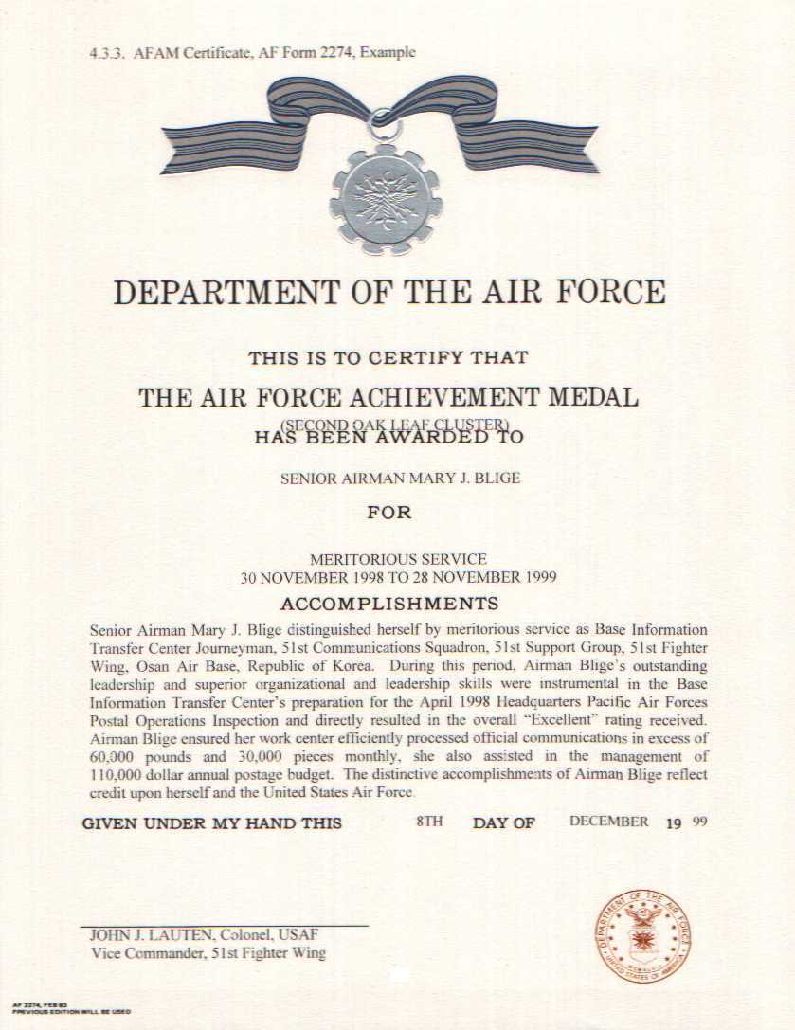
4.4. Air Force Commendation Medal (AFCM)

4.4.1. Criteria for Submission

4.4.1.1. Awarded for outstanding achievement or meritorious service, or acts of courage that do not meet the requirements for award of the Airman’s Medal or the Bronze Star Medal, and sustained meritorious performance by crew members.

4.4.1.2. Do not award to general or flag officer grade.

4.4.1.3. Place emphasis on award to outstanding company grade officers and junior NCOs whose achievements and services meet the standards.

4.4.2. Format

      - The AF Form 2224, Air Force Commendation Medal Certificate, citation, DECOR 6, highlighted EPR/OPR’s, and the 51 FW Form 121, Decoration Justification/Indorsement are required in all packages

4.4.2.2. Citation (orientation is landscape)

4.4.2.2.1. Font: Times New Roman, 12 point. All print type throughout the citation must be the same.

4.4.2.2.2. Margins:
Top - 1 to 1 1/2 inches
Sides - 1 to 2 inches, fully justified
Bottom - minimum of 3 inches

4.4.2.2.3. Center horizontally the following lines:

CITATION TO ACCOMPANY THE AWARD OF
(one blank line)
THE AIR FORCE COMMENDATION MEDAL
(FIRST OAK LEAF CLUSTER)
(one blank line)
TO
(one blank line)
JAMES M. BROWN, JR.
(three blank lines)

4.4.2.2.4. Include the recipient’s social security number (SSN) three spaces after the name on all copies (3) (except the original). Center the name only, not the SSN.

4.4.2.2.5. Opening sentences

4.4.2.2.5.1. Meritorious service

Technical Sergeant James M. Brown, Jr., distinguished himself by meritorious service as Noncommissioned Officer in Charge, Administrative Support, 51st Aerospace Medicine Squadron, 51st Medical Group, 51st Fighter Wing, Osan Air Base, Republic of Korea, from 7 January 1998 to 5 January 1999.

OR

Technical Sergeant James M. Brown, Jr., distinguished himself by meritorious service while assigned to 51st Aerospace Medical Squadron, 51st Medical Group, 51st Fighter Wing, Osan Air Base, Republic of Korea, from 7 January 1999 to 5 January 1999.

4.4.2.2.5.2. Outstanding achievement

Technical Sergeant James M. Brown, Jr., distinguished himself by outstanding achievement (an act of courage) (at or near) on 20 May 1999.

4.4.2.2.6. Closing sentences

4.4.2.2.6.1. PCS/PCA/extended tour/outstanding achievement

The distinctive accomplishments of Sergeant Brown reflect credit upon himself and the United States Air Force.

4.4.2.2.6.2. Retirement

The distinctive accomplishments of Sergeant Brown culminate a (long and) distinguished career in the service of his country and reflect credit upon himself and the United States Air Force.
4.4.2.2.6.4. Separation

The distinctive accomplishments of Sergeant Brown while serving his country reflect credit upon himself and the United States Air Force.

4.4.2.3. Certificate (Air Force Form 2224)

4.4.2.3.1. Font: Times New Roman, Bold Face,12 point. All print type throughout the certificate must be the same and in capital letters (except for the signature block area).

4.4.2.3.2. Center horizontally the following information:

4.4.2.3.2.1. Oak leaf cluster data (if applicable) one blank line under “THE AIR FORCE COMMENDATION MEDAL.”

4.4.2.3.2.2. Rank, first name, middle initial, and last name one blank line below “HAS BEEN AWARDED TO.”

4.4.2.3.2.3. Enter meritorious service, outstanding achievement, or an act of courage one blank line under “FOR.”

4.4.2.3.2.4. Enter inclusive dates under meritorious service, outstanding achievement, or an act of courage. The Dates are always written as either single or double digits:

Correct: 7 JANUARY 1999 TO 5 JANUARY 2000
Incorrect: 07 JANUARY 1999 TO 05 JANUARY 2000

4.4.2.3.2.5. The “Given under my hand date” must be computer generated, DO NOT USE A TYPE WRITER. Ensure the date is after the close out date of the decoration.

Correct: THIS 3D DAY OF JUNE 1999
Incorrect: THIS 3RD DAY OF JUNE 1999

4.4.2.3.2.6. Directly under line on left side of certificate, enter 51st Fighter Wing Commander’s first name, middle initial, and last name (in all upper case). On second line, enter rank, (spelled out, upper/lower case) and USAF. On third line, enter Commander, 51st Fighter Wing (upper/lower case).

4.4.3. Citation Example

CITATION TO ACCOMPANY THE AWARD OF

THE AIR FORCE COMMENDATION MEDAL
(FIFTH OAK LEAF CLUSTER)

TO

JAMES M. BROWN, JR., FR123-45-5678

Technical Sergeant James M. Brown, Jr., distinguished himself by meritorious service as Noncommissioned Officer in Charge, Administrative Support, 51st Aerospace Medicine Squadron, 51st Medical Group, 51st Fighter Wing, Osan Air Base, Republic of Korea, from 9 June 1998 to 7 June 1999. During this period, Sergeant Brown’s outstanding performance as Physical Examinations Board Liaison Officer led to identifying over 26 high risk medical cases, 13 being returned to the United States for definitive care and allowing critically manned positions to be filled with mobility qualified personnel. His attention to detail led to an unprecedented zero percent error rate on packages sent to the Headquarters Air Force Personnel Center. His outstanding procedures in processing pregnancy profiles in less than 2 days, well below Air Force standard of 10 days, was lauded by the Headquarters United States Air Force Inspector General Team. His superb leadership skills was instrumental in selecting him as the 51st Aerospace Medicine Squadron’s Noncommissioned Officer of the Year and nomination for Headquarters Pacific Air Forces’ Outstanding Enlisted Health Services Management Award. The distinctive accomplishments of Sergeant Brown reflect credit upon himself and the United States Air Force.

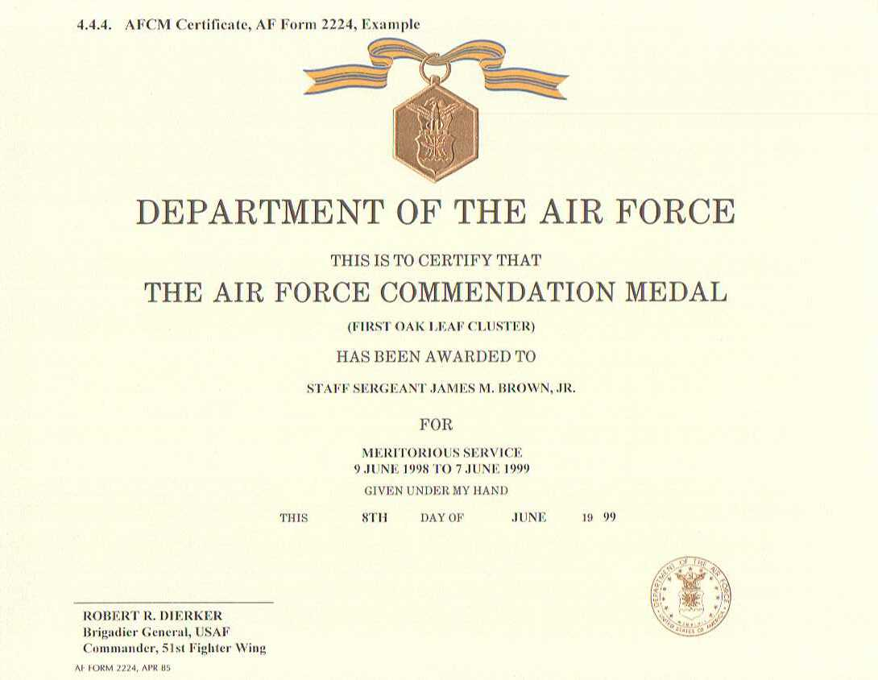
4.5. Meritorious Service Medal (MSM)

4.5.1. Criteria for Submission

4.5.1.1. Awarded for outstanding noncombat meritorious achievement or service to the United States.

4.5.1.2. Level of achievement or service is less than required of a Legion of Merit.

4.5.1.3. Do not award for foreign military personnel in the grade of brigadier general or higher.

4.5.2. Format

4.5.2.1. The AF Form 2228, Meritorious Service Medal certificate, DÉCOR 6, highlighted EPR/OPR’s, and 51 FW Form 121, Decoration Justification/Indorsement are required in all packages.

        - Font: Times New Roman, 12 point. All print type throughout the certificate must be the same.

4.5.2.1.2. Margins: Left and right margins should be 1 inch fully justified

4.5.2.1.3. Center horizontally and vertically the following lines:

4.5.2.1.4. Number of oak leaf clusters (in all capital letters) below “THE MERITORIOUS SERVICE MEDAL”

4.5.2.1.5. Rank and name (in all capital letters) below “TO”

4.5.2.1.6. Outstanding achievement or meritorious service (in all capital letters) below “FOR”

4.5.2.1.7. Date line (in all capital letters), below “FOR” and meritorious service or outstanding achievement. Dates are always written as either single or double digits.

Correct: 27 JUNE 1999 TO 8 JUNE 2000
Incorrect: 27 JUNE 1999 TO 08 JUNE 2000

4.5.2.1.8. Directly under the GIVEN UNDER MY HAND put the date. Ensure the date is after the close out date of the decoration.

Example: If a decoration closes out on 8 June 2000, the date that should appear under the GIVEN UNDER MY HAND is 9 JUNE 2000 or any date after that.

4.5.2.1.9. Directly under line on left side of certificate, enter 51st Fighter Wing Commander’s first name, middle initial, and last name (in all upper case). On second line, enter rank, (spelled out, upper/lower case) and USAF. On third line, enter Commander, 51st Fighter Wing (upper/lower case).

4.5.2.2. Opening sentences

4.5.2.2.1. Outstanding service

Major Aretha B. Franklin distinguished herself in the performance of outstanding service to the United States as Chief Dispatcher, Vehicle Operations Flight, 51st Transportation Squadron, 51st Logistics Group, 51st Fighter Wing, Osan Air Base, Republic of Korea, from 18 May 1999 to 20 May 2000.

OR

Major Aretha B. Franklin distinguished herself in the performance of outstanding service to the United States while assigned to the Vehicle Operations Flight, 51st Transpiration Squadron, 51st Logistics Group, 51st Fighter Wing, Osan Air Base, Republic of Korea, from 18 May 1999 to 20 May 2000.

4.5.2.2.7. Closing sentences

4.5.2.2.7.1. PCS/PCA, extended tour

The singularly distinctive accomplishments of MajorFranklin reflect great credit upon herself and the United States Air Force.

4.5.2.2.7.2. Retirement

The singularly distinctive accomplishments of Major Franklin culminate a (long and) distinguished career in the service of her country and reflect great credit upon herself and the United States Air Force.

4.5.2.2.7.3. Separation

The singularly distinctive accomplishments of Major Franklin while serving her country reflect great credit upon herself and the United States Air Force.

4.5.2.3.2.5. Directly under line on left side of certificate, enter 51st Fighter Wing Commander’s first name, middle initial, and last name (in all upper case). On second line, enter rank (spelled out, upper/lower case), and USAF. On third, enter Commander, 51st Fighter Wing (upper/lower case).

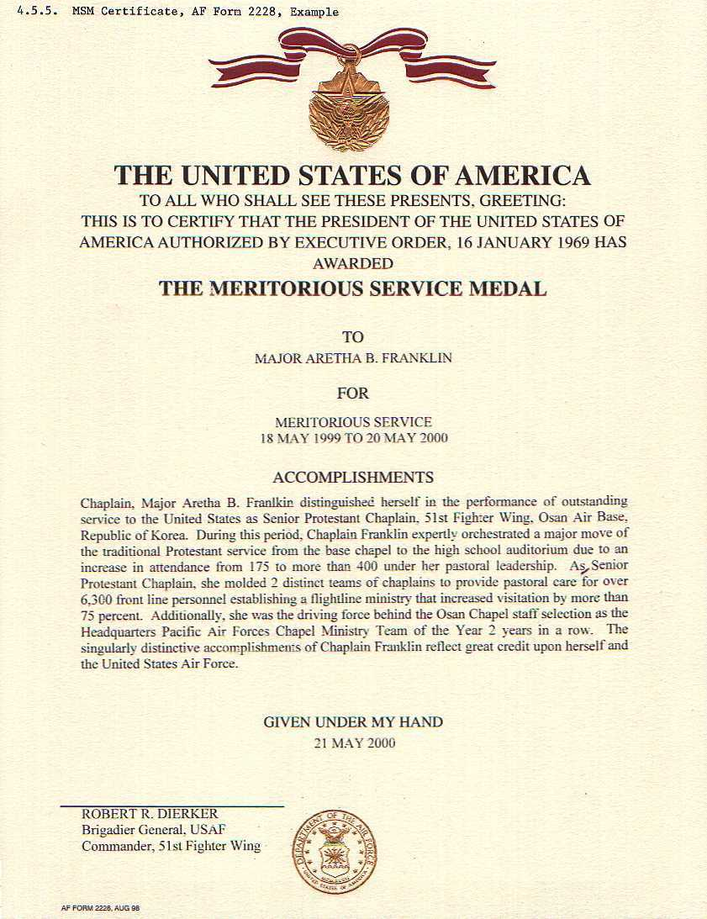
Aerial Achievement Medal (AAM)

    - Criteria for Submission

      - Recognize aircrew members involved with operating aircraft or other personnel performing aircrew member duties. The recommendations must clearly substantiate exceptional performance and outstanding airmanship above that normally expected of professional airmen.

4.6.1.2. Awarded for sustained meritorious achievement while participating in aerial flight. MAJCOMs, FOAS, DRUs will identify the missions and positions to qualify for the award. Not awarded for single event flights.

    - Format

4.6.2.1.The AF Form 2275, Aerial Achievement Medal Certificate, citation, DECOR 6, letter signed by the group commander, and the 51 FW Form 121, Decoration Justification/Indorsement are required in all packages

4.6.2.2. Citation (orientation is landscape)

4.6.2.2.1. Font: Times New Roman, 12 point. All print type throughout the citation must be the same.

4.6.2.2.2. Margins:
Top - 1 to 1 1/2 inches
Sides - 1 to 2 inches, fully justified
Bottom - minimum of 3 inches

4.6.2.2.3. Center horizontally the following lines:

CITATION TO ACCOMPANY THE AWARD OF
(one blank line)
THE AERIAL ACHIEVEMENT MEDAL
(FIRST OAK LEAF CLUSTER)
(one blank line)
TO
(one blank line)
RONALD D. MCDONALD
(three blank lines)

4.6.2.2.4. Include the recipient’s social security number three spaces after the name on all copies (5) (except the original). Center the name only, not the SSN.

        - Opening sentence

Colonel Ronald D. McDonald distinguished himself by meritorious achievement while participating in sustained aerial flight a A/OA-10 Pilot, 25th Fighter Squadron, 51st Operations Group, 51st Fighter Wing, Osan Air Base, Republic of Korea, from 23 Jun 1998 to 15 October 1998.

4.6.2.2.6. Closing sentence

The professional ability and outstanding aerial accomplishments of Colonel McDonald reflect
great credit upon himself and the United States Air Force.

CITATION TO ACCOMPANY THE AWARD OF

THE AERIAL ACHIEVEMENT MEDAL
(FIRST OAK LEAF CLUSTER)

TO

RONALD D. MCDONALD

Captain Ronald D. McDonald distinguished himself by meritorious achievement while participating in sustained aerial flight as A-10 Pilot, 25th Fighter Squadron, 51st Operations Group, 51st Fighter Wing, Osan Air Base, Republic of Korea, from 21 December 1998 to 12 May 1999. During this period, Captain McDonald flew 10 close air support missions, in the Republic of Korea’s Prohibited Area-518 Tactical Zone, in support of combined United States and Republic of Korea ground forces. All missions within within Prohibited Area-518 require exacting attention to detail and continuous vigilance as flight into this area places the pilot and aircraft within the tactical effective range of enemy threat systems and in close proximity to the Korean Buffer Zone. Captain McDonald’s outstanding pilot skills, flight discipline and expert tactical knowledge supported the readiness and ability of the United States Air Force to enforce the Korean Armistice while protecting its ally the Republic of Korea. The professional ability and outstanding aerial accomplishments of Captain McDonald reflect great credit upon himself and the United States Air Force.

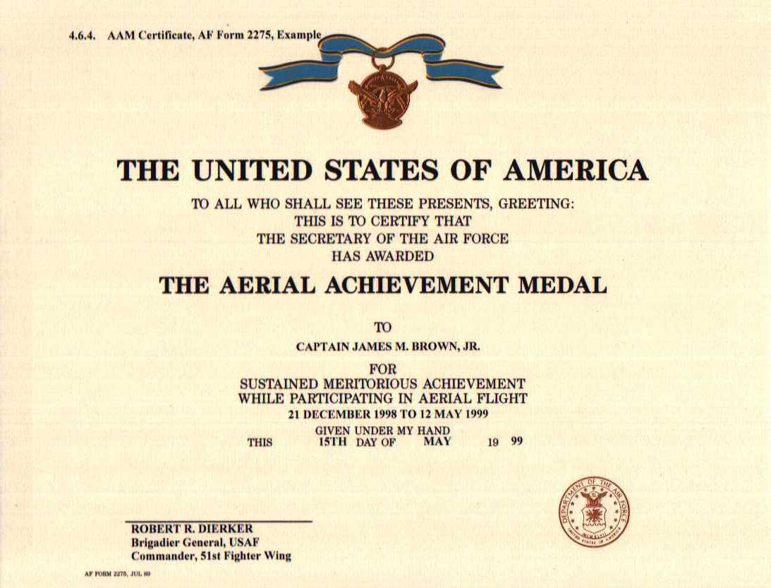
4.7. Legion of Merit (LOM)

4.7.1. Criteria for Submission

4.7.1.1. Awarded for exceptionally meritorious conduct in the performance of outstanding service to the United States. In peacetime, awards to US military personnel are limited to recognizing:

4.7.1.1.1. Service in an extremely difficult duty that is performed in a clearly exceptional manner, if such service is of marked national or international significance or of marked significance to the Air Force or the Department of Defense.

4.7.1.1.2. Service that has aided the United States in furthering its national policies.

4.7.1.1.3. Service that has furthered the interest or the security of the United States.

4.7.1.1.4. Service that has furthered the interests or the security of the United States, or any nation allied or associated with the United States during a period of national emergency declared by the President or the Congress.

4.7.1.1.5. Superior performance of normal duties will not alone justify award of this decoration.

4.7.1.2. Do not award for heroism.

      - As LOMs require higher headquarters approval, retirement LOMs (approved by
HQ PACAF) should arrive at MPF not later than 60 days prior to desired presentation date. LOMs for PCS (approved by HQ USAF) should arrive at MPF not later than 75 days prior to desired presentation date.

4.7.2. Format

4.7.2.1. Justification is limited to a one-page narrative or bullet format.

4.7.2.1.1. Font: Times New Roman, 12 point. All print type throughout the citation must be the same.

4.7.2.1.2. Margins: top, bottom, and sides - 1/4 to 1 inch. Ensure enough room is available for a signature block.

4.7.2.2. Citation (orientation is landscape)

4.7.2.2.1. Font: Times New Roman, 12 point. All print type throughout the citation must be the same.

4.7.2.2.2. Margins: Top - 1 to 1 1/2 inches
Sides - 1 to 2 inches, fully justified
Bottom - minimum of 3 inches

4.7.2.2.3. Center horizontally the following lines:

CITATION TO ACCOMPANY THE AWARD OF
(one blank line)
THE LEGION OF MERIT
(one blank line)
TO
(one blank line)
ROY T. SMITH
(two blank lines)

4.7.2.2.4. Include the recipient’s SSN two spaces after the name on all copies (except the original). Center the name only, not the SSN.

4.7.2.2.5. Do not use the words “long and” in the closing sentence unless the member is retiring with 30 or more years service.

4.7.2.2.6. No misspelled words, smudges, light print, or anything that detracts from the appearance will be allowed.

4.7.2.2.7. Opening sentences

4.7.2.2.7.1. Outstanding service

Colonel Roy T. Smith distinguished himself by exceptionally meritorious conduct in the
performance of outstanding services to the United States as Vice Commander, 51st Fighter Wing, Osan Air Force Base, Republic of Korea, from 20 August 1999 to 31 July 2002.

4.7.2.2.7.2. Outstanding achievement

Colonel Roy T. Smith distinguished himself by outstanding achievement as JOINT HOPE Legal Coordinator, Seventh Air Force, Osan Air Base, Republic of Korea, from 20 February 1999 to 25 April 1999.

4.7.2.2.8. Closing sentences

4.7.2.2.8.1. PCS/PCA, extended tour

The singularly distinctive accomplishments of Colonel Smith reflect great credit upon herself and the United States Air Force.
4.7.2.2.8.2. Retirement

The singularly distinctive accomplishments of Colonel Smith culminate a (long and) distinguished career in the service of his country and reflect great credit upon himself and the United States Air Force.

4.7.2.2.8.3. Separation

The singularly distinctive accomplishments of Colonel Smith while serving her country reflect great credit upon herself and the United States Air Force.

4.7.2.3. Certificate (Air Force Form 2240) is accomplished by HQ PACAF or HQ USAF.
4.6.3. Justification Example

Colonel Roy T. Smith distinguished himself by exceptionally meritorious conduct in the performance of outstanding services to the United States as Vice Commander, 51st Fighter Wing, Osan Air Base, Republic of Korea, from 7 July 1998 to 30 September 1999. In this important assignment, the leadership, exemplary foresight, and ceaseless efforts consistently demonstrated by Colonel Smith resulted in significant contributions to the effectiveness and success of the 51st Fighter Wing. As the vice commander of the most forward-deployed fighter wing in the United States Air Force, Colonel Smith impacted and influenced all wing and base operations. Directly responsible for the wing’s wartime readiness, Colonel Smith implemented a demanding base-wide exercise program to include 13 major and four supporting exercises involving the wing and base tenant units. To implement permanent improvements based on exercise experiences, Colonel Smith conceived and chaired the wing’s Command and Control Working Group, bringing together functional experts and change agents throughout the wing. Through this group, Colonel Smith leveraged the fielding of a new automated Wing Command and Control System by implementing new paradigms in command and control that vastly improved crisis response while reducing support staff manning by 30 percent. Under his leadership, Osan Air Base, exercise planning encompassed Seventh Air Force, 51st and 8th Fighter Wings requirements to bring about the Korea-wide Air Force Combat Employment Readiness Exercise. The direct results of these efforts were measured by the Headquarters Pacific Air Forces Inspector General’s April 1999 Korea-wide Combat Employment Readiness Inspection in which the 51st Fighter Wing received an overall “Excellent” rating. Not content to just impress the Inspector General, Colonel Smith set out to make substantive improvement in the wing’s ability to operate in a long-duration chemical environment. These warfighting and readiness efforts were enhanced by Colonel Smith’s leadership and constant attention to Air Force standards as evidenced in during the Headquarters Pacific Air Forces’ Inspector General’s November 1998 Initial Response Readiness Inspection. While preparing the 51st Fighter Wing for any wartime contingency, Colonel Smith was the focal point for Osan’s environmental issues. As the chair of the Osan Air Base Environmental Protection Committee, Colonel Smith made tremendous strides in improving the environment at Osan Air Base through diligent planning and continual monitoring of all available resources. Due directly to his leadership prowess, Colonel Smith was asked to be the Osan Air Base Company Grade Officers Council advisor. Under his tutelage, the Company Grade Officers Council more than tripled its membership thru team building, networking skills and experience brought to the council by Colonel Smith. In the wing commander’s absence, Colonel Smith assumed command of the 51st Fighter Wing and flawlessly addressed all issues ranging from high-level distinguished visitors through combat readiness, force protection and quality of life. The singularly distinctive accomplishments of Colonel Smith reflect great credit upon himself and the United States Air Force.

ROBERT R. DIERKER
Brigadier General, USAF
Commander

HAPTER 5

HELPFUL HINTS

5.1. Format Reminder

5.1.1. Day must not be separated from the month. Only the month and year may be separated.

5.1.2. Unit numeric designation must not be separated from the unit name.

5.1.3. Rank must not be separated from the name.

Example:

CORRECT

Master Sergeant Janice K. Doe distinguished herself in the performance of outstanding service to the United States as Noncommissioned Officer in Charge of Awards and Decorations, 50th Combat Support Squadron, 50th Tactical Fighter Wing, Hahn Air Base, Germany, from 14 October 1984 to 21 December 1986. During this period, Sergeant Doe consistently demonstrated outstanding technical skill in dealing with the many complex subjects of the Personal Affairs Office. She contributed immeasurably in the successful mission accomplishment of the 50th Tactical Fighter Wing and the Air Force. The singularly distinctive accomplishments of Sergeant Doe reflect great credit upon herself and the United States Air Force.

INCORRECT

Master Sergeant Janice K. Doe distinguished herself in the performance of outstanding service to the United States as Noncommissioned Officer in Charge of Awards and Decorations, 50th Combat Support Squadron, 50th Tactical Fighter Wing, Hahn Air Base, Germany from 14 October 1984 to 21 December 1986. During this period, Sergeant Doe consistently demonstrated outstanding technical skill in dealing with the many complex subjects of the Personal Affairs Office. She contributed immeasurably in the successful mission accomplishment of the 50th Tactical Fighter Wing and the Air Force. The singularly distinctive accomplishments of Sergeant Doe reflect great credit upon herself and the United States Air Force.

5.1.4. When speaking about a specific individual don’t use the individuals name, use their title or position.

CORRECT

Sergeant Wright provided excellent graphic support during the President of the United States visit to Osan Air Base, Republic of Korea. She received kudos from the Commander, 51st Fighter Wing, for all her hard work and dedication.

INCORRECT

Sergeant Wrong provided excellent graphic support during the President of the United States, Bill Clinton's visit to Osan. She received kudos from Brigadier General Robert R. Dierker, the Commander 51st Fighter Wing, for all her hard work and dedication.

5.1.5. When using quotations in a sentence ensure that the quotations proceed the period.

CORRECT

His phenomenal handling skills during the 1998 United States Forces Korea K-9 Competition resulted in his selection as the “Top Dog” award winner and the wing “charger of the week.”

INCORRECT

His phenomenal handling skills during the 1998 United States Forces Korea K-9 Competition resulted in his selection as the “Top Dog” award winner and the wing “charger of the week”.

    - A decoration is considered late if it is received at the wing after the close out date of the decoration. However, a late letter is only required if the decoration arrives to the wing 20 or more days after the close out date.

5.1.7. When using compound grade titles, such as First Lieutenant, Staff Sergeant, and so on, spell out the complete grade title in opening sentence and then use the short title in the balance of the citation. Reflect the title “Chaplain” as “Chaplain, grade, full name” in the opening sentence. Thereafter, reflect “Chaplain Surname.”

5.1.8. Decorations will not be accepted at the command section before 2 weeks prior to the closeout date.

5.2. Checklist YES NO
1. Are all required documents in the decoration package completed IAW this guide?

2. Are sufficient copies of the required items in the package?
AFAM
1-51 FW Form 121, Decoration Justification/Indorsement (signed by
supervisor/squadron commander/group commander and dated)
1-AF Form 2274, Certificate, in document protector (original)
1-DECOR 6 (signed by supervisor/squadron commander)
Copies of EPR/OPR’s highligted (ensure draft copies have inclusive dates and are
marked in the appropriate blocks)
AFCM
1-51 FW Form 121, Decoration Justification/Indorsement (signed by
supervisor/squadron commander/group commander and dated)
1-AF Form 2224, Certificate, in document protector (original)
1-Citation, without SSN, in document protector
5-Citation, with SSN, in document protector
1-DECOR 6 (signed by supervisor/squadron commander
Copies of EPR/OPR’s highligted (ensure draft copies have inclusive dates and are
marked in the appropriate blocks)

MSM
1-51 FW Form 121, Decoration Justification/Indorsement (signed by
supervisor/squadron commander/group commander and dated)
1-AF Form 2228, Certificate, in document protector (original)
1-DECOR 6 (signed by supervisor/squadron commander)
Copies of EPR/OPR’s highligted (ensure draft copies have inclusive dates and are
marked in the appropriate blocks)

AAM
1-51 FW Form 121, Decoration Justification/Indorsement (signed by
supervisor/squadron commander/group commander and dated)
1-AF Form 2224, Certificate, in document protector (original)
1-Citation, without SSN, in document protector
5-Citation, with SSN, in document protector
1-DECOR 6 (signed by supervisor/squadron commander
Copies of EPR/OPR’s highligted (ensure draft copies have inclusive dates and are
marked in the appropriate blocks)

LOM
1-Citation, without SSN, in document protector
1-Citation, with SSN, in document protector
1-Justification (either narrative or bullet)
1-DECOR 6
1-Computer disk with all documents

3. Are margins on citation IAW AFI 36-2803?
4. Is appropriate font used on all documents (Times New Roman, 12 point)?
5. Do the inclusive dates match the justification, citation, certificate, and DECOR 6?
6. Are appropriate opening/closing sentences used IAW AFI 36-2803?
7. Are the citation and certificate free of acronyms and abbreviations?
8. Ensure there are no subscripts used 51st
9. Is the appropriate oak leaf cluster indicated on all documents (if applicable)?
10. Are documents printed on quality printer and free of smudges?

