75 MSS EPR/OPR/PRF WRITING GUIDE



Thanks for taking a look at our EES and OES guide. We hope it will help in your use of these systems.

The guide contains the distilled knowledge of many personnel specialists, senior raters, and participants in recent selection boards. The format emphasizes the who, what, when, why, and how of each aspect of the two systems. We believe this will help people who are not familiar with the systems to find the information they need.

Remember, this is a guide, not a directive. We provided suggestions to help, not hinder you. Be creative. Be innovative. Strive to provide useful feedback and well-written reports. The actions we take as raters and evaluators within these systems will determine who will advance in rank and responsibility and who will not. We owe our Air Force and our people our best possible effort.

Section I: THE SYSTEMS
Enlisted Evaluation System (EES)
Officer Evaluation System (OES)

Section II: WRITING
Communicating Through the EES and OES
Deciding What to Say
How to Say It Well
Board Member Perspectives

Section III: ADMINISTRIVIA
Timeliness
Endorsement/Review Levels
Acquisition Examination Statements
Close Out Dates
Separations
Format
Mandatory PIF and UIF Review
Common Mistakes
Fixing Mistakes

Section IV: FORMS
Feedback
Enlisted Performance Reports
Officer Performance Reports
Referral Reports
Promotion Recommendation Forms

Section V: MANAGEMENT LEVEL REVIEWS (MLRs)
Process
Timeliness
Responsibilities

The Enlisted Evaluation System and Enlisted Promotions

The Air Force's Enlisted Evaluation System (EES) influences enlisted promotions. This guide addresses two parts of the EES, the performance feedback sessions provided to airmen and NCOs, and the performance reports produced to document their duty performance during a given period of time. Performance feedback is critical in telling an individual what duty performance is expected and how well the individual is meeting those expectations. Feedback itself, however, does not have a direct impact on the enlisted promotion system. The enlisted performance report (EPR) does have a direct impact; however, the relative importance of different sections of the performance report varies based on the grade to which the individual is being considered for promotion.

Promotions to Airman (Amn) and Airman First Class (A1C) are based on the commander's recommendation and time-in-grade (TIG) provided the individual is otherwise eligible. Normally, promotion to Senior Airman (SrA) is based on commander’s recommendation and TIG; however, there is an opportunity to be promoted to SrA 6 months early (Below-the-Zone (BTZ). Competition for BTZ promotion takes place at a base or unit board. The overall promotion recommendation block and the rater and rater’s rater comments on the competitors' EPRs are considered by board members and are important to the selection process.

Airmen compete for promotion to Staff Sergeant (SSgt), Technical Sergeant (TSgt), and Master Sergeant (MSgt) under the Weighted Airmen Promotion System (WAPS). WAPS combines scores on subjective tests (Specialty Knowledge Test (SKT) and a Promotion Fitness Examination (PFE)) with a time weighted average of numerical promotion recommendations from EPRs for the last 5 years (up to 10 reports), and points for TIG, time-in-service (TIS), and decorations. The EPR score makes up 29 percent of the available points.

Performance reports are used in two different ways for promotion to Senior Master Sergeant (SMSgt) and Chief Master Sergeant (CMSgt). These NCOs also take a test (USAF Supervisory Exam) as part of their promotion process and receive points for TIG, TIS, decorations, and a numerical score for the promotion recommendations on past EPRs. Weighted performance report scores for the last 5 years can contribute up to 135 of the 360 available points. In addition to this WAPS phase, a selection board also scores their records. The board considers performance reports for the last 10 years, academic education, and completion of professional military education. Evaluator comments and level of endorsement (see page 13) on performance reports can heavily influence board scores, which will range from 270 to 450 points out of a possible 810 points. The board score and the WAPS score are combined to rank order eligibles in each AFSC. The Air Force determines the number of people promoted to SSgt through CMSgt each cycle.

References: AFI 36-2406, Officer and Enlisted Evaluation Systems
AFI 36-2502, Airman Promotion Program
The Officer Evaluation System and Officer Promotions

The Officer Evaluation System (OES) was designed to help ensure the best-qualified officers advance in rank and responsibility. The OES uses three types of communication: performance feedback between the supervisor and the officer, the performance report the supervisor writes to document what the officer did during a given period, and a promotion recommendation the officer's senior rater writes to help members of a promotion board judge the officer's potential for promotion. Like the EES, performance feedback is a key component. Feedback is the primary means of ensuring each officer understands what the supervisor expects and how well the officer meets those expectations. The feedback session itself is private between the rater and ratee; however, commanders are authorized to verify completion of the session. Feedback forms do not become a matter of record and they do not have a direct role in the officer promotion system.

Officer performance reports (OPRs) comprise the bulk of an officer's record and they are the primary means of judging an officer's potential for promotion. The form is designed to highlight the officer’s contributions to mission accomplishment. A series of reports by different evaluators in a variety of duty situations provides a cumulative record of an officer’s development, performance, and potential compared to his or her contemporaries.

The promotion recommendation form (PRF) provides additional performance-based differentiation to assist central selection boards. Some board members believe the PRF is the single most important document in a selection folder since the PRF introduces the officer to the central selection board. While not binding, traditionally, a "Definitely Promote" (DP) or "Do Not Promote This Board" recommendation has wielded considerable influence on the board. "DP" allocation rates are established to ensure a significant percentage of those individuals who receive a "Promote" recommendation will, in fact, be promoted.

The allocation of DP recommendations for officers competing In/Below-the-Promotion Zone (I/BPZ) are based on the number of people eligible for promotion in those two categories and the rank for which they are being considered. Eligibility is determined by year-group (the year the officers began their commissioned service) or the officer's date of rank. Officers promoted Above-the-Promotion Zone (APZ) after their contemporaries or Below-the-Promotion Zone (BPZ), 1 or 2 years ahead of their contemporaries, join a new year-group.

The final, official allocation of I/APZ DPs takes place 66 days prior to the day the central selection board convenes. When a unit does not have enough officers to earn a DP allocation, its officers may compete for DPs with officers from other units in the same situation in what is known as "Aggregate" competition. For BPZ, this takes place at the first level in the organization's chain of command that has a sufficient number of officers to be allocated one or more DPs. I/APZ aggregation in AFMC is held at the major command (MAJCOM) headquarters and takes place at the management level review (MLR).
Senior raters throughout the MAJCOM with eligible officers comprise the MLR. They perform a quality review of all of the command's competing officers' records and PRFs before a central selection board convenes. They also serve as a composite senior rater for units that do not have enough eligibles to earn their own DP allocations (aggregate competition). The MLR also provides a second opportunity for officers in the command to compete for a DP. This takes place in the Carry Over competition. Carry Over DPs are derived from rounding down each senior rater's DPs to a whole number. For example, if a senior rater had 12 IPZ captains eligible for promotion to major, the number 12 would be multiplied by the allocation rate for DPs (65 percent) for a total of 7.8. The senior rater would be able to award 7 DPs and the .8 would be added with the other fractions created in this process throughout the command. The total of all the fractions becomes the number of DPs available in Carry Over competition. Carry Over DPs are derived from rounding down each senior rater’s DP to a whole number.

It is important to remember that officers compete for promotion in their respective competitive categories; i.e. line, nurse, chaplain, dental, medical, judge advocate, biomedical sciences, and medical service corps. The promotion opportunities and DP allocations for non-line officers vary for each selection board. Always read the guidance provided for each board carefully to ensure you understand all of the factors that apply.

Officers are responsible for ensuring their records are accurate and complete. Commanders’ support staffs (CSS) and servicing Military Personnel Flights (MPF) can help ensure records have all the appropriate documentation prior to a selection board. Officers may also contact the Air Force Personnel Center (AFPC) to review their records prior to meeting a selection board. Copies of officer selection folders may be obtained from:

HQ AFPC/DPPBR1 Voice: DSN 665-2371
550 C Street West, Suite 5 FAX: DSN 665-4255
Randolph AFB TX 78150-4707

Requests for records must be made in writing (include name, address, and SSN). Microfiche copies will be provided in most cases.

Educational records must be updated through the Air Force Institute of Technology's (AFIT) Admissions Registrar Directorate. AFIT automatically updates its graduates' records. All officers are welcome to check to ensure their records are accurate. To do so, call the telephone number listed below and ask for the classification and coding section. To have information from a civilian institution added to your record, provide an official transcript to:

AFIT/RRE Voice: DSN 785-7293
Bldg 125, 2950 P Street FAX: DSN 785-2791
Wright-Patterson AFB OH 45433-7765

References: AFI 36-2406, Officer and Enlisted Evaluation Systems
AFI 36-2501, Officer Promotions and Selective Continuation
Communicating Through the OES and EES

WHY

Performance reports document what the ratee did during the period of evaluation and how well he or she did it. This documentation helps boards and senior leadership choose the best people for promotions, schools, assignments, and in making other sound decisions.

WHO

Key players in this process are:

Ratee - The subject of the report.

Rater - The ratee’s supervisor--the person directly responsible for the ratee’s work and the one who gives the ratee performance feedback. The rater must serve in a grade equal to or higher than the ratee (for grade requirements, see Endorsement Levels).

Additional Rater - The next person beyond the rater in the chain of command, usually the rater’s rater. The additional rater must serve in a grade equal to or higher than the rater and in a grade higher than the ratee.

Senior Rater/Reviewer - Wing or center commander or equivalent who reviews the contents of the report to ensure accuracy and fairness (for required grade levels, see Endorsement Levels).

Readers - The author of any report has two sets of customers: the subject of the report (the ratee), and the people who will read the report. For the former, the report serves as the official documentation of months of effort and will be the basis of pivotal career decisions. The latter is a vast group with widely varying rank, experience, and knowledge of the Air Force. This second set of customers will use reports and other documentation to compare the ratee to other members of his or her peer group when making decisions about promotions, assignments, and other key selections. To serve both of these customers, the report must be accurate and well written.

Many supervisors find it difficult to report all of the things an individual did and convey an accurate sense of his or her skills and leadership qualities in the small space available on the OPR and EPR forms. Words must be chosen carefully, bullet statements must be honed to razor sharpness, nuances considered, and narrative blocks balanced against one another. The objective in writing any report should be first, to decide what to say; then, to say it well.
Deciding What to Say

Both the officer and enlisted promotion systems are designed to reward people who perform well and have demonstrated they have the potential to succeed in positions with broader responsibility. Because of this, raters need to address a full range of factors, from technical and professional competence to general management and leadership ability when they write reports. Raters must also differentiate between individuals' levels of performance to ensure the best qualified people advance in grade and responsibility and those less qualified do not. It is crucial to the credibility of both EES and the OES.

Specific Professional Skills

Raters should document how well their people perform in the skills considered essential in their career fields. These skills are demonstrated most clearly in daily job performance, making job performance the most important thing to discuss in any report. Use the impact on the duty section’s mission and the importance of a particular skill to the ratee’s career field to decide which specific aspects of job performance to highlight. There should be a greater emphasis on basic technical skills in both junior enlisted members’ and junior officers’ reports than in mid-level NCO or mid-level officer reports. These are typical examples of comments from junior enlisted and company grade officer reports:
- Meticulous at all times! Processed 600 leave forms flawlessly allowing…
- Quickly mastered the intricacies of computer-aided design enabling the lab to…

Management

Whether we manage our own time or billions of dollars of taxpayers' money, everyone in the Air Force is involved in some form of management. Management skills can be addressed in many different ways. Like technical skills, the first priority is to discuss them in terms of their impact on the unit’s mission. A few examples:
- Developed new tracking procedures for vehicles--doubled use, saved $10,000 this year
- Systematically analyzed contractor cost proposal--found $30K over-pricing others missed
- Incorporated four major modifications valued at $100 million into a practical Programmed Depot Maintenance program
Leadership! Leadership! Leadership!

It is always important to discuss leadership. Selection boards look for indications of leadership and leadership potential. Leadership is a less tangible quality than technical or management skills, but it can be defined roughly as the ability to get things done. It is not limited to supervisory skills. People who are catalysts within research or product teams and work centers are leaders. People who are recognized for setting standards in their profession are leaders. People who win other people’s support and funding for projects clearly show leadership. All of these things are appropriate material for comment in a performance report. These are examples of leadership bullets related to acquisition and scientific duties:
- Constructed innovative risk-sharing/cost-saving strategies to motivate government-industry team
- Saw need for, then initiated $15 million high-fidelity, simulation prototype to demonstrate space-based management concepts to users
- Focused the efforts of my integration team--we’re moving to seamless C4I!
Extra Curricular Activities

Although job performance is always the most important thing for the rater and other evaluators to address, an individual's performance in additional duties and special projects and involvement in areas outside the scope of normal duties often provide valuable insight into his or her management and leadership skills. Activities raters may comment on include, but are not limited to:
- Significant additional duties (unit security manager, safety officer)
- Awards (NCO of the Quarter, Company Grade Officer of the Year, Best in Air Force, etc.)
- Special projects (base Combined Federal Campaign coordinator, project officer for wing commander’s retirement ceremony)
Sometimes comments on activities outside of the Air Force will also help create a stronger impression of the ratee’s abilities. These include, but are not limited to:
- Significant volunteer community service (Big Brothers & Sisters, scouting)
- Professional society activities (president of local chapter of Air Force Sergeants' Association, chairs local chapter of Society of Military Comptrollers)
- Civilian awards (named one of Outstanding Young Men of America, American Business Women’s Association Woman of the Year)

Although references to these accomplishments can be valuable, they should never be used to the exclusion of strong, mission-related performance information. A report that emphasizes additional duties and community involvement to a greater degree than it highlights valuable contributions to the mission will hurt the ratee’s chances for selection for promotion. This type of report gives readers the impression the person spent little energy in his or her primary job, or could easily be spared for outside activities, an indication that he or she was not a valued contributor.

Teamwork

From squadrons on the flight line to any shop or office, the Air Force is a compilation of official and unofficial teams. In AFMC, teamwork is particularly important because much of our mission involves working in formal team situations, either with contractors, members of other major commands, or people with diverse expertise. How an individual performs as a member of these teams is a crucial measure of his or her value to the organization as a whole. Raters need to consider teamwork carefully and comment on it. Does this person participate actively, offering ideas and expertise, or sit on the sidelines? Does he or she meet commitments and suspenses established by the team? Can the ratee accept the team position and advocate it even when not in full agreement with it? This information will help anyone reading an EPR or OPR determine if the ratee has the capacity to not only function within teams, but to advance and lead.

Recommendations for the Future

Raters can offer opinions about the type of assignments the ratee is prepared to assume. A statement such as "my next superintendent," "NCOIC material," "an easy pick for branch chief," or "command is a must" give readers a valuable perspective on the ratee’s capabilities. While comments on enlisted reports can imply that the ratee should be promoted, comments on officer reports cannot. Be careful not to address specific grades when commenting on an officer’s potential. For example, referring to a captain as a "good choice for a squadron command" would be acceptable because the job is not tied to a specific grade, but commenting that a captain should have "a job with field grade responsibility" would be unacceptable because it emphasizes only the rank.

Raters can also recommend their people attend certain schools. The most significant recommendations are for professional military education (PME) in residence. For officers, Squadron Officer School (SOS), Intermediate Service Schools (ISS) {usually Air Command and Staff College (ACSC}, and Senior Service School (SSS) {Air War College, National War College, Industrial College of the Armed Forces}. PME recommendations should be included on the OPRs of all officers the rater believes should attend PME. Omitting a school recommendation is a clear signal to selection board members that the rater does not believe the officer should attend.

Officers can also attend Defense Systems Management College (DSMC) and advanced degree programs offered by the Air Force Institute of Technology (AFIT). Both DSMC and AFIT provide important educational opportunities, but recommendations for these schools are not as important to an officer’s career development as PME. It is important to make DSMC and AFIT recommendations on OPRs; however, they are not substitutes for PME recommendations.

Recommendations for Regular Air Force (RegAF) commission, “Augmentation” are currently allowed. However, individuals selected for major will be offered RegAF. Therefore, evaluators may mention RegAF in the officer’s OPR. We recommend the space be better used for other accomplishments, issues, and recommendations.

Caution: recommendations for the wrong school hurt the raters’ credibility and send an ambiguous message to readers. Officers are eligible to attend SOS when they have 4-7 years of commissioned service, ISS as majors, and SSS as lieutenant colonels or colonels. Also, recommending an officer to attend a school well beyond his or her eligibility (recommending a lieutenant for ISS) is considered an illegal promotion statement.

Tips: Use ISS, ACSC, and SSS to save space. DSMC is not as well known as the PME schools and AFIT. It is helpful to provide some explanation of its importance, such as "the acquisition equivalent of Fighter Weapons School."

How to Say it Well

The keys to a well-written performance report are clarity, action, and tone. Clarity ensures the readers understand what the writer meant. Action keeps the focus on what the ratee did, and tone conveys how much the author values the ratee’s contributions. Follow a simple, logical progression in each bullet statement. The most common and successful pattern is: what the ratee did, how the ratee did it, and the impact of that action. An example:
- Masterfully served as interim dental laboratory officer; maintained continuity of quality care
- Reorganized administrative procedures directly leading to increased security of precious metals

You can help board members judge the relative merits of your ratees' performance if you can help them understand how important his or her contributions are. You can do this by asking yourself:

How much time, money, or resources were saved (shaving 3 months from the test schedule, cutting production time 25 percent)? Did his or her efforts lead to something important (on contract in half the normal time, avoiding protracted or costly renegotiations)? Were defects reduced or eliminated, improving the product (making the system more reliable, improving system performance)?

How much better does the process work? (Twice as fast, four-fold improvement in customer satisfaction)

How important was this effort to the user or customer? (Praised by using command or operational community, rated best provider by customers)

How rare is this skill? (One of three experts in command, only one in DoD)

Where was the impact of the action felt? (center, command, Air Force, DoD)

Which weapon system was affected? (only one model, a class of weapons spanning DoD)

Finer Points for Clarity

Do not use terms that your readers are unlikely to understand. It is safe to assume your readers are military members or Department of Defense (DOD) civilians. Although they will probably be familiar with terms like deployment, headquarters, and secretariat, they probably will not be familiar with the language specific to a particular specialty, function, or command. Use the simplest terms possible to describe your unit’s mission and your people’s accomplishments.
Spell-out full titles the first time they appear and include the acronym in parenthesis after it. The Air Force uses thousands of acronyms. Do not assume that your readers are familiar with all of them.

Avoid ambiguous words and phrases. Don’t leave your reader wondering what you meant. Consider the statement "keep this officer challenged." It is not negative, but not necessarily positive either. Has this officer failed to master his or her current job? Does this officer need close supervision?

Present strong evidence for strong statements. Kudos like "Best in the Air Force" are credible only when backed up with facts like Air Force and DoD-level awards.

Choose your words carefully. Be accurate. Was this person the team leader, a team member, or the team’s most valuable player?

Cut all extraneous words. This sharpens the impact of your words and saves space. Be specific. This shows impact and lends credibility to your statements.

Tip: ask someone outside of your organization to read the report and give you their impression of it. If this reader understands it, chances are board members will too.

Action!

The easiest way to emphasize the ratee’s action is to write in active voice. In an active voice sentence the subject performs the action. This should follow naturally because the ratee is the subject of all bullet statements. Active voice allows you to squeeze the maximum information into short phrases. It eliminates the need for extra clarifying words and uses the simplest past tense forms of verbs. Examples:

Active - Single-handedly processed 350 claims in 3 weeks to resettle Homestead AFB evacuees quickly
- Passive – In excess of 350 claims were processed by Airman Sharp single-handedly in three-week period, helping Homestead evacuees to resettle quickly
- Active - Developed database to provide previously unavailable customer requirement data--saves time!
- Passive - Has developed a database that provides previously unavailable data for projecting customer requirements--an important aid in achieving effective utilization of man-hours!

Word Choice

Another factor in emphasizing action is your choice of verbs and descriptive words. Vivid verbs make your comments compelling. Bland verbs do not. Some examples:
Vivid Verbs | Bland Verbs
Cut | Assisted
Created | Aided
Drove | Contributed
Guaranteed | Coordinated
Infused | Employed
Instituted | Maintained
Led | Monitored
Saved | Participated
Spearheaded | Reviewed

The same principle applies to the other characterizing words. Strong descriptive words leave a lasting impression with readers. Dull and monotonous accounts of what someone did give your reader the impression that the person you are talking about is average at best. Differentiation is very important. There are appropriate times to use less impressive statements, but be sure you have made a conscious decision about the message you want to send. Some examples:

Strong Adverbs and Adjectives | Bland Adverbs and Adjectives
Adroitly | Adequate
Deftly | Capable
Diplomatically | Dependable
Dynamic | Effective
Energetic | Fine
Expertly | Potential
Rapidly | Ready
Persuasive | Sturdy

Tone

It is very important to give readers a sense of how much you value the ratee’s contributions. Enthusiastic narratives convince readers the ratee is a valued contributor. Sedate reports do not. Writing in active voice helps convey a sense of enthusiasm because it emphasizes what the "doer" (the ratee) accomplished, but tone is primarily a matter of word choice and phrasing. The number and degree of superlatives, or the lack of them provide variations in tone, as do exclamation points--and phrases set off by double bullets!

Original and unusual word choices catch readers’ attention. Some people believe that copying verbs and phrases from the reports of people who were promoted recently will improve their ratees’ chances of selection. This is not necessarily true. Words or phrases that appear on hundreds of reports lose their impact. Also keep in mind that enthusiastic words will not impress anyone if they are not coupled with specific examples. Former board members relate they gave little credence to reports filled with "arm waving." Write with enthusiasm, but rely on the evidence you present to impress your readers.

Do not cross the border from enthusiastic to trite or cute. Consider these examples:
"A walk-on-water kind of guy!" | This says nothing relevant about the ratee's skills and may offend some people.
"Firmly convinced he could nail Jell-O to the wall and make it stick if I asked him to!" | Enthusiastic, but like the previous example, it does not provide credible documentation. It is more entertaining than it is persuasive.
"Quality is her Job 1" | Advertising slogans should not creep into performance reports. Someday, the commercial will be forgotten and this will be gibberish.
Help Your Reader Understand

Many readers will be unfamiliar with the types of duties performed in specific organizations and what duties are normally performed by people of which ranks. That makes it difficult for them to judge the significance of the ratee’s accomplishments. Supplying this information can help readers identify people already performing above their grade-level. For example: "only NCO on this influential product team" or "first captain selected as branch chief in this directorate."
Appearance Counts

Sloppy reports can hurt people. Misspellings, typos, badly smudged documents, and misaligned bullet statements give readers a poor impression. Also consider the amount of space used. A minimalist approach can have a very dramatic impact, positive or negative. The space allotted for narrative comments is usually too small to elaborate on all the important things a ratee did. That makes reports with large empty spaces stand out. If the few words used make a bold, definitive statement and are supported by sufficient facts, the report will impress anyone who reads it. If the words are not enthusiastic, or the few accomplishments listed are not impressive, the report will probably leave readers with the impression the ratee did very little. One caution, squeezing too much data into a block or manipulating the words simply to fill space also hurts a report. Obvious filler does not make a report persuasive.

Differentiate

Board members need to be able to tell the difference between good, average, and poor performers during selection boards. Accurate descriptions of ratee’s performance provide some natural differentiation, but a rater can help or hinder the board based on their choices of words. Avoid using the same descriptive words and phrases on every report. Board members notice when the same phrases appear on several reports from the same unit, or the same phrases are repeated on reports in an individual’s record. At best, these statements are ignored. At worst, they leave the reader with a negative impression.

Ranking statements are one effective way to differentiate. These statements describe or compare the officer or NCO to the rest of the organization or his or her professional peers. However, make sure rank ordering comments are quantified. If you rank order the ratee, for example, "TSgt Smith is simply the best TSgt," finish the statement with "of twenty TSgts in my division" or a similar comparison. Another caution--stating that the ratee is "within the top 10% of all captains” implies that the rater was qualified to judge how well all captains in the Air Force perform their duties. You can say that the ratee “is within the top 10% of all captains in my group/division” or "best of 43 captains in this SPO." Also remember, there can be only one "best" or "my #1" in a given category.
Board Member Perspectives

A dozen AFMC colonels who participated in recent promotion boards offer the following insights.

At Enlisted Promotion Boards (Senior and Chief Master Sergeant)

Good Reports:

- Leadership evident in the job descriptions
- Clear job descriptions
- Duty titles denoted position of responsibility
- Senior raters’ assessments of relative standing "best in my wing"
- Hard hitting endorsements and enthusiasm from senior rater
- Recognition for job-related work (Quarterly, MAJCOM and Air Force Awards)
- Credited ratee for unit’s strong performance in IG and other inspections

Bad Reports:
- Confusing job description
- Lackluster words in endorsements
- Jargon, jargon, and more jargon
- Glittering generalities
- Lacked results
- Repeated words from the Job Description in rater’s assessment

Additional comments from two CMSgts who were board members on the CY98 SMSgt Evaluation Board may be found at Attachment 1.

At Officer Promotion Boards (Major and Lieutenant Colonel)

Good Reports:
- Had hard-hitting, specific facts
- Highlighted awards
- Presented strong word pictures
- Superlatives were backed up by facts
- Showed achievements that were over and above "doing the job"
- Enthusiasm! Enthusiasm! Enthusiasm!
Bad Reports:
- Lacked specific individual accomplishments
- Were filled with meaningless generalities and trite phrases
- Left impression the person came to work each day but didn’t do much else
- Did not describe contributions to war-fighters or unit mission
- Lacked enthusiasm and favorable comparison to peers
- Had too much "techno talk"

The Administrative Aspects of Report Preparation

Nothing is more frustrating than having an EPR or OPR bounced back from the commander’s office, the MPF, or AFPC because of administrative errors. The following pages address the basic mechanics of the report process and the most common problems associated with them. Procedures for routing and reviewing reports vary from base to base. Contact the Commander’s Support Staff and the MPF that serves your unit to learn what process you should follow.

Timeliness

EPRs for TSgts & below are to be filed in the Unit Personnel Record Group (UPRG) in the MPF within 60 calendar days after their close out date. The original copy of EPRs for MSgts and above and OPRs for Lt Cols & below are filed at HQ AFPC/DPPBR1 within 60 calendar days after the report's close out date. Copies of OPRs are "due to file" in the UPRG and Officer Command Selection Record Group (OCSRG) at the MAJCOM’s Personnel Directorate, and EPRs are "due to file" in the UPRG within 60 calendar days after close out. MPFs mail the copies. Although reports are not due to be filed until 60 calendar days after close out, every effort should be made to finalize reports as soon as possible for people meeting promotion boards. MLRs and central selection boards (CSBs) will accept reports until the day the boards actually convene.

Endorsement/Review Level

If the ratee is: | The reviewer/final evaluator must be:
AB - TSgt | Rater’s rater, grade requirement is MSgt or GS-7, if raters’ rater is not at least a MSgt or GS-7, report is closed out by first person in chain of command at that level or higher
MSgt - CMSgt | Major or GS-12, final may be of higher rank
2Lt - Maj | Colonel or GS/GM-15, serving as wing commander or in designated senior rater position
Lt Col - Col | General Officer or Senior Executive Service member, includes Brigadier General selects serving in a designated senior rater position

Rater Requirements - EPRs

AB thru TSgt, AF Form 910, only. An AF Form 910 must be endorsed by the rater’s rater unless that person does not meet the minimum grade requirements (MSgt or GS-07). If the rater’s rater does not meet the requirement, the next person in the rating chain who does will endorse the EPR.

MSgt thru CMSgt, AF Form 911 only. The final evaluator of an AF Form 911 must be at least a major or GS-12, but no higher in the organizational structure than the senior rater. Senior raters may endorse EPRs in the following situations only:

- When necessary to meet minimum grade requirements
- If the senior rater is a mandatory endorser because of his or her position in the chain of command (the rater or rater’s rater)

The senior rater may designate someone else to endorse the report if that person has sufficient knowledge of ratee’s duty performance and meets minimum grade requirements.

- When the ratee is a CMSgt or CMSgt select
- When the ratee meets the time-in-grade eligibility requirements found on the EPR notice (see AFI 36-2406, table 3.2, note 15, for additional guidance on time-in-grade eligibility)

Senior Rater Requirements - EPRs

The senior rater for time-in-grade eligible MSgts and above is defined in AFMC Commander's Policy Directive 90-12, AFMC Rating Chain. Senior rater endorsement is considered a "highly coveted" endorsement and is used by the Central Selection Board to differentiate between SNCOs. Therefore, extreme care should be taken to ensure a senior rater doesn't diminish the weight of his/her signature by signing reports where a senior rater endorsement may not be warranted. When determining if a senior rater endorsement is appropriate, use the whole person concept to determine potential for advancement. Although not a go/no go indicator, factors such as PME completion, Community College of the Air Force awarded degrees, distinctive awards (SNCO of the Quarter, etc.) and community involvement may be indicative of the initiative, desire, and potential to serve in the top two SNCO grades. These factors, along with job performance and depth and breadth of experience should allow a senior rater to properly allocate endorsements to those truly deserving promotion.

Rater Requirements - OPRs

The reviewer for majors and below must be at least a colonel or GM/GS-15 occupying a wing commander or equivalent position that has been designated a senior rater position by the management level (MAJCOM). The reviewer for lieutenant colonels and colonels is the first general officer (this includes a brigadier general select occupying a senior rater position) or SES in the rating chain. Some acquisition officers have unusual rating chains. Consult AFMCPD 90-12 for more information on rating chains for acquisition officers and determining senior raters.

Squadron Commander Review (EPRs)

The squadron commander reviews all EPRs before sending them to the MPF to be filed and before the rater’s rater or endorser, who is senior to the commander, signs it. Normally, the commander will sign the report as the reviewer without adding comments. The commander only provides comments when:

- The commander signs the report as an evaluator (rater, rater’s rater, or endorser)
- The report is a referral and the commander is the evaluator named in the referral letter
- The commander disagrees with the report

If the commander disagrees with something in the report, he or she marks the "nonconcur" block, signs in the space provided, initials the rating blocks he or she determines appropriate, and adds comments on an AF Form 77 giving one or more specific reasons for disagreeing with the rater or previous evaluator. The squadron commander review does not apply to OPRs. Commanders sign OPRs as evaluators only.

Acquisition Examination Statements

Performance reports prepared on people occupying acquisition positions must be reviewed by a person who serves in the same acquisition functional category. The Air Force requires this review for all officers and enlisted members in designated acquisition positions. For example, if Capt Doe serves in a "program management" position, and his rater, additional rater, or reviewer is also in a "program management" position, one of them may sign the acquisition examination statement on the report as long as they are designated as an acquisition examiner. This review ensures all acquisition-related considerations have been properly documented on the report.

If no one in the rating chain occupies a position in the same acquisition functional area as the ratee, a colonel, or civilian equivalent occupying a position in the same acquisition functional area will be appointed to review the report. If there is no colonel or equivalent in that functional area on your base, the report is forwarded to HQ AFMC/DPMQP, and an examiner at HQ AFMC will be assigned to perform the acquisition review. The acquisition examination is documented in Block IX of AF Forms 707A/B, and in the front-left margin of AF Forms 910 and 911.

Close Out Dates
Normally, the close out date is 365 days (1 year) after the previous EPR’s close out date. This is called an “annual” report. If the ratee has had two or more raters within the annual rating period, the close out date may be established when the ratee has had 120 calendar days of supervision under his or her current reporting official. This is called a “change of reporting official (CRO)” report. If the close out date is extended beyond 365 days due to changes in reporting official, only 60 days of supervision are required under the current reporting official to establish a close out date, not the normal 120 days.

Separations
A rater may opt to write a final report on someone retiring. If a SSgt or above (including officers) is separating from active duty but will serve in the Reserves (AD or non-AD), he or she can come back to active duty or be called back into the military. Because of that, an EPR or OPR is required on everyone who separates and will serve in any capacity in the Reserves. A report may be required when a member is being discharged involuntarily. If one is required, the rater will be notified by the servicing MPF.

Format
Most raters prepare narrative sections of reports in bullet format. This is mandatory for some sections on reports (see below). Bullet statements allow the writer to pack more information into small spaces than full sentences do. In a bullet statement, there is no need to state the subject, (the assumed subject is the ratee). They normally begin with a verb ("Led," "Chosen") or a descriptive word or phrase ("None better in . . ." "Fastest"). Bullet statements should conform to the same general rules of grammar as a sentence, but need not adhere as strictly to normal punctuation and syntax. For example, comma splices that would be unacceptable in normal correspondence are permitted in a bullet statement, and words like "the" and "a" can usually be omitted. Each bullet statement in an EPR is limited to three lines in length. Although there is no rule governing the length of bullet statements in OPRs, most organizations remain within the three-line limit. Bold face, non-standard CAPITALIZATION, and extra exclamation points are taboo!!!!

Format for OPRs: Section IV, "Mission Impact," must be written in bullet statements. The vast majority of raters in AFMC use bullet format for their comments in Section VI, "Rater Overall Assessment," and Section VII, "Additional Rater Overall Assessment," and some raters have established policies for their organizations mandating this. Job descriptions may be written in bullet format.

Format for EPRs: The text in all of the comment sections on both AF Form 910, Enlisted Performance Report (AB thru TSgt), and AF Form 911, Enlisted Performance Report (MSgt through CMSgt), must be written in bullet format. Job descriptions may be written in bullet format.

Mandatory PIF and UIF Review
Raters and commanders must review all officers’ Personal Information Files (PIFs) and Unfavorable Information Files (UIFs) for derogatory information prior to completing OPRs, decoration recommendations, and Promotion Recommendation Forms. This ensures they are aware of all pertinent information on the officer prior to completing these key actions. However, realizing the administrative problems these reviews could cause, there is some flexibility in meeting this requirement. Senior raters may opt to have subordinate commanders or equivalents certify review of the PIF and forward only significant information to the senior rater for review. The senior rater can then either certify that they have reviewed the information or that none existed. Procedures vary. Make sure you are aware of the processes that apply in your organization.

Common Mistakes to Avoid
Make sure you use the correct form and the most current version of that form. The latest versions as of 15 Apr 2000 are:

Rank | Correct Form
AB thru TSgt | AF Form 910 (20000601)
MSgt thru CMSgt | AF Form 911 (20000601)
Company Grade Officers (Captain & below) | AF Form 707B (20000601)
Field Grade Officers (Major thru Colonel) | AF Form 707A (20000601)
*Note: Performance feedback worksheets are dated as follows: AF Form 931, 20000101; AF Form 932, 20000101; AF Form 724A 20000101; and AF Form 724B, 20000101.

Ensure the "thru" and "from" dates are correct ("thru" dates are different for each type of report). For an annual report, the "thru" date is 1 year from the close out date of the previous report. The close out ("thru") date for a CRO due to PCS is normally 30 days prior to departure. For other CROs, the report will close out the day before the effective date of change. The "from" date should be either the day after the ratee’s last report closed or the ratee’s Extended Active Duty (EAD) date.

- Make sure all concur/nonconcur blocks are marked appropriately
- Ensure there are no promotion statements on OPRs (includes implied statements)
- Do not discuss officers' involvement in positions of grades higher than they currently hold.
- Example: "Capt Smith is filling a field grade officer's billet" is an illegal statement.
- For OPRs, make sure the final evaluator has been designated as a senior rater (see Endorsement Levels)

Fixing Mistakes

If a mistake is found before the report is filed in the MPF or HQ AFPC personnel record, the report should be corrected or reaccomplished. If the mistake is found after the report has been made a matter of record (filed), then it must be determined whether the error is considered "minor." Minor corrections include ratee identification data, "from" and "thru" dates, AFSCs, unmarked blocks, incorrect number of days of supervision, or incorrect PAS codes. Minor corrections can be made by the MPF. The MPF will make the necessary notifications to
HQ AFPC and the MAJCOM.

If the mistake is in a narrative block, it cannot be corrected by the above means (because the correction could affect the comments' meaning, ratings, or endorsement level). In these situations, use an AF Form 948, Application for Correction/Removal of Evaluation Report to correct the report. These forms are available at the MPF's evaluations office. The evaluations office processes this form when complete. A corrected copy of the report, signed by all raters, should be included with AF Form 948. MPFs provide their customers with detailed instructions on how to fill out the form and what documentation to attach. AFI 36-2401, Correcting Officer and Enlisted Evaluation Reports, also contains complete, step-by-step instructions.

Performance Feedback (AF Forms 931, 932, 724A, and 724B)

WHAT

Performance feedback is formal communication between a rater and ratee. The rater should use this time to explain duty performance requirements and responsibilities, establish expectations, and inform the ratee if he or she is performing as expected. Feedback does not take the place of day-to-day supervision, informal feedback, formal counseling, or casual conversations about expectations and duty performance.

WHO

Initial feedback sessions are mandatory for all enlisted personnel and for officers in the grades of lieutenant through colonel. Mid-course feedback sessions are mandatory for Lt Cols-Lts and SMSgts-ABs. Follow-up feedback sessions are mandatory for Capts-Lts and TSgts-ABs

WHEN

Initial feedback sessions are held within 60 days of a change of rating official; mid-course feedback sessions are held midway between the date supervision began and the projected OPR/EPR close out date; and follow-up feedback sessions are held within 60 days of the close out of an OPR/EPR. Raters are responsible to schedule feedback sessions to avoid conflicts with TDY, leave, and changes of reporting official, when possible, but ratees should also keep track of when feedback sessions are due. Normally, the CSS will send a feedback notice to the supervisor to alert him or her that a feedback session is due, but the supervisor is accountable for ensuring the feedback sessions are scheduled on time whether or not a performance feedback notice is received.

A rater may schedule additional feedback sessions at any time.

A ratee may request a feedback session. The session will be completed within 30 days of the request provided at least 60 days have passed since the last feedback session.

HOW

Only two people attend a feedback session: the rater and the ratee. It should be conducted face-to-face, in a private setting such as an office or conference room, and it must be recorded on the appropriate Performance Feedback Worksheet (PFW). Occasionally, unforeseen circumstances may make it impossible for the rater and ratee to meet face-to-face within the time period prescribed for a feedback session. If there is no way for these people to get together, it is permissible to hold a feedback session by telephone, but telephone feedback should be rare.

The rater handwrites or types, signs, and gives the completed PFW to the ratee at the conclusion of the feedback session. The rater must keep a copy of the PFW for future reference. Besides the rater and ratee, the only people authorized access to PFWs are those in the EPR rating chain for TSgts and below, and commanders for SNCOs. Raters certify a feedback session has been accomplished by returning a copy of the performance feedback notice with the date of the feedback session and signatures of both the rater and ratee to the CSS office. If the rater did not receive a feedback notice, he or she may document the session with a memo for record or other written statement signed by both the rater and rate that provides the date the feedback took place. The documentation is filed in the ratee's Personal Information File (PIF) in the CSS office.


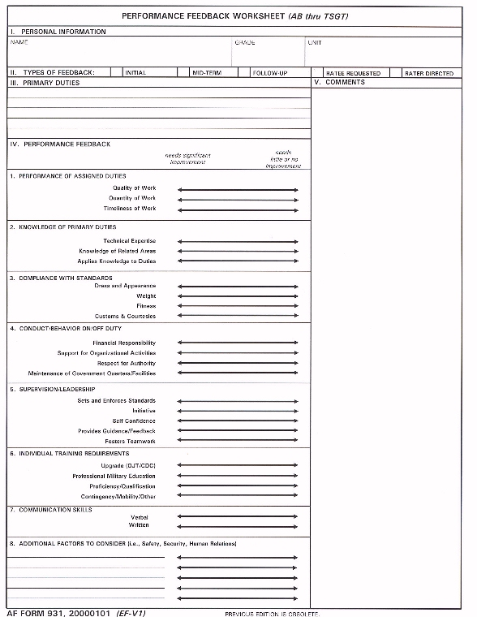

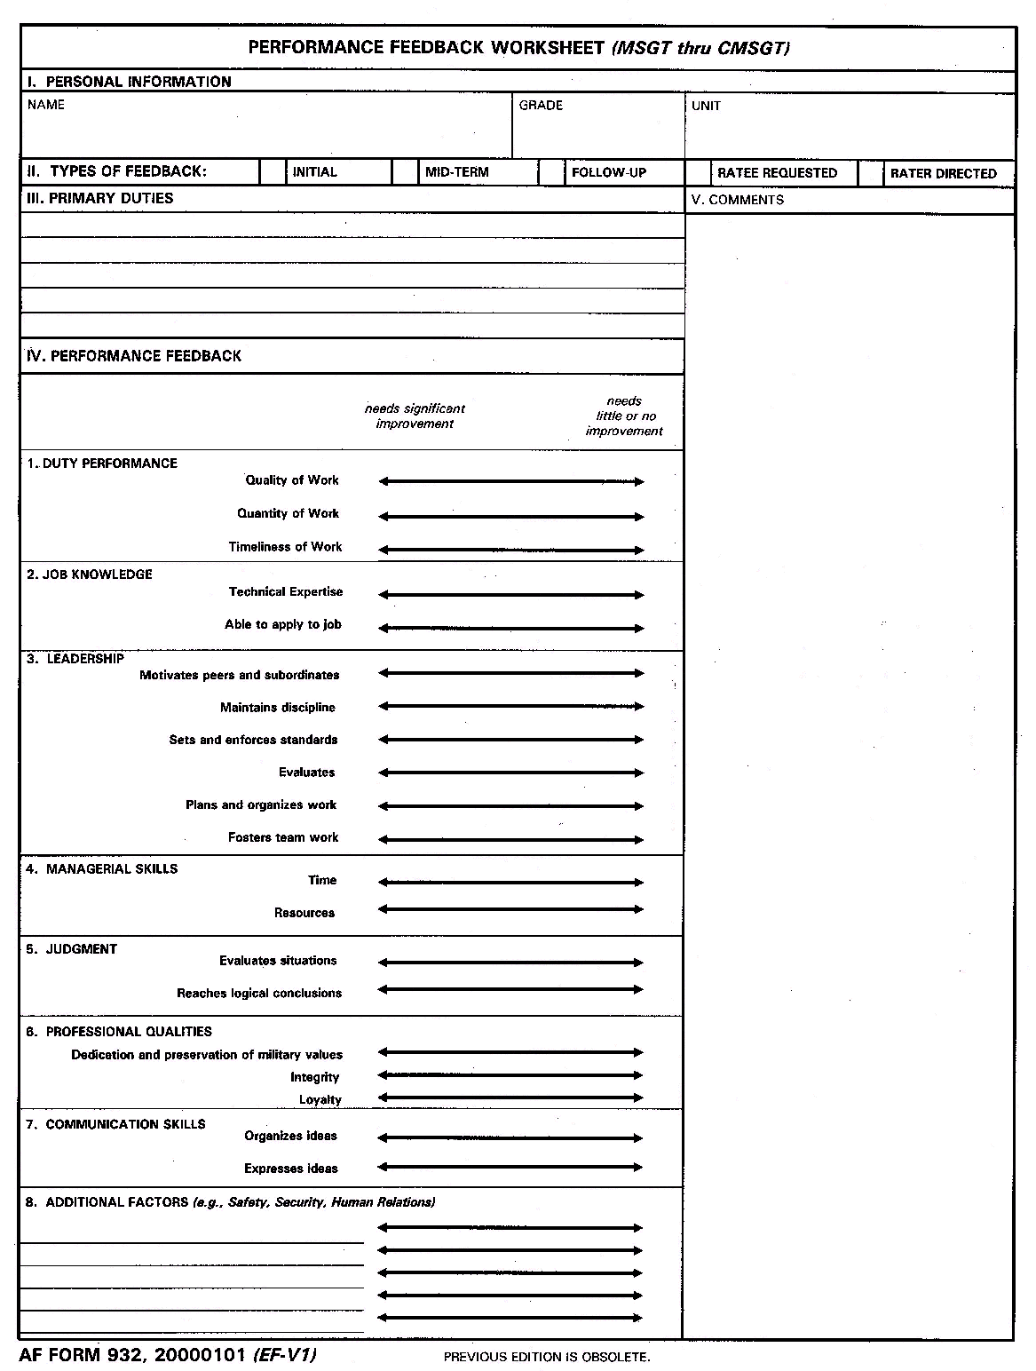
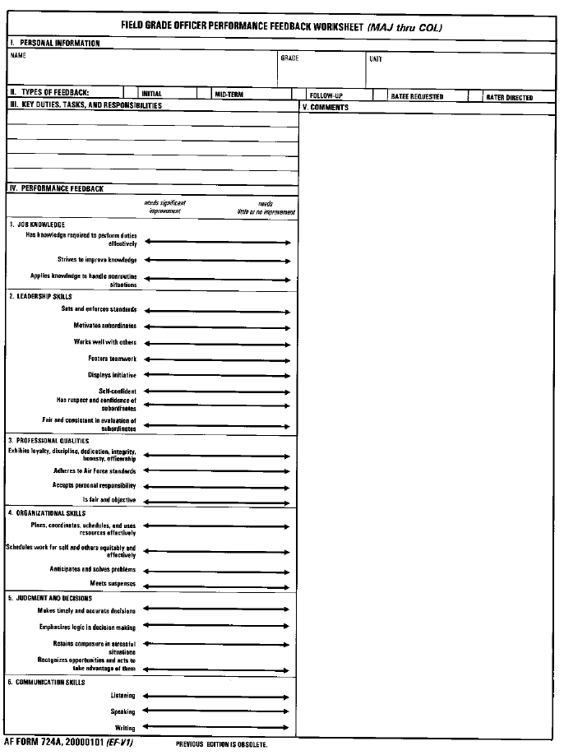
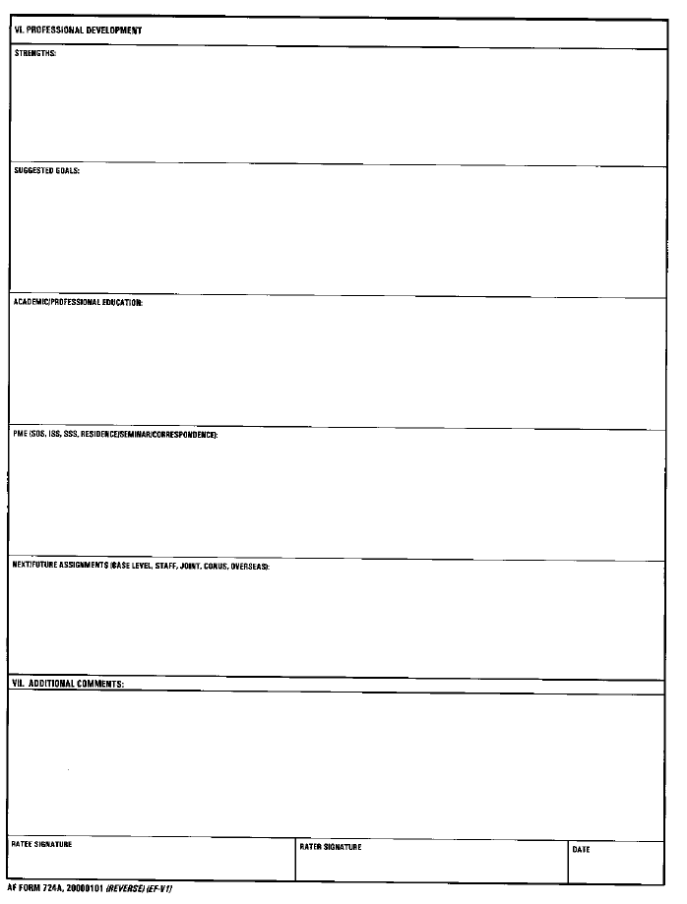

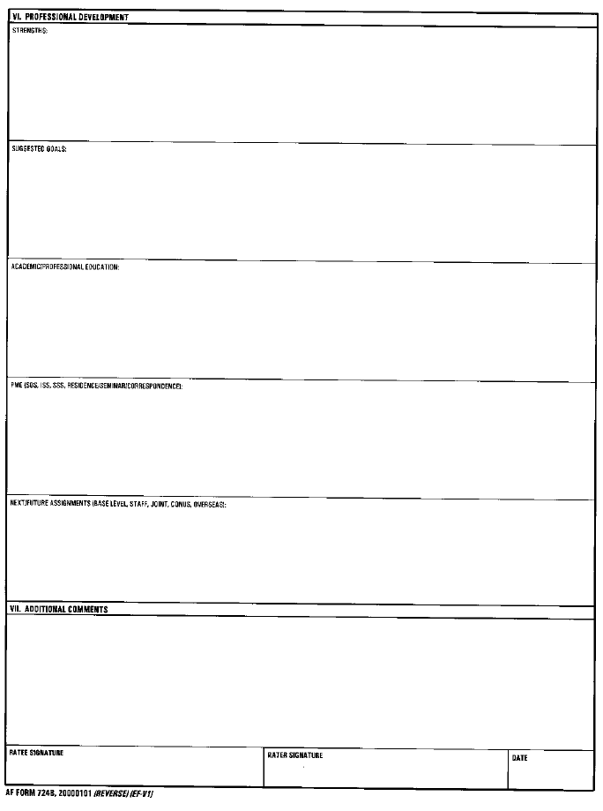

Enlisted Performance Report (AF Forms 910 & 911)

WHAT

An Enlisted Performance Report (EPR) is an official record of an enlisted person's performance over a specific period. AF Form 910 is used for Airmen Basic (AB) through Technical Sergeants (TSgts), and AF Form 911 is used for Master Sergeants (MSgts) through Chief Master Sergeants (CMSgts).

WHO

All enlisted people receive EPRs. The ratee’s grade on the date the EPR closes out determines whether the rater will use the form for AB-TSgt or MSgt-CMSgt for the report. Normally, a rater must supervise the ratee for 120 days before he or she can write an EPR. This period of supervision may be reduced to 60 days if more than a year has passed since the ratee's last EPR was completed. The period of supervision is also reduced to 60 days if the ratee is an Amn or A1C with 20 or more months of Total Active Federal Military Service (TAFMS) and has not had an initial report yet, or if the rater is writing a referral report.

WHEN

There are five events that trigger the requirement for an EPR. They are:

Initial | Written when an Amn or A1C has 20 months of TAFMS
Annual (365 days) | Written 1 year after the last EPR closed out for all SrA through CMSgt (also applies to Amn and A1C 360 days after initial report closed out)
Change of Reporting Official (CRO) | Written when rater changes as result of official PCS, PCA, or there was an approved change of designated rater
Directed by Headquarters (DBH) | HQ USAF directs DBH that a report be written. Common reasons: A1C has no EPR on file but is competing for SrA Below-the-Zone, MSgt slated to meet promotion board, but has not had a report since the previous board met
Directed by Commander | The unit commander can direct a report be written at any time provided there are 60 days supervision

When one of these events occurs, the ratee's CSS will send a notice, known as a shell, to his or her rater. The notice contains all of the personnel data needed to complete the report.
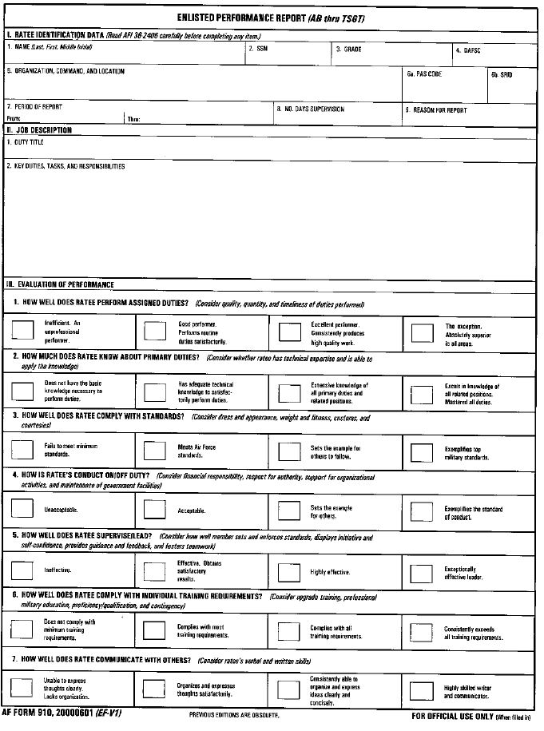
Ratee Identification Data

Take this information from the notice produced by your CSS office.

Duty Title

Use the duty title that appears on the notice. Duty titles can be changed at your CSS office.

Job Description

This narrative describes the ratee's duties. It should give a clear explanation of his or her responsibilities within the unit and scope of authority. Tasks should be described in simple terms that anyone in the Air Force would understand. The job description can be changed by the rater without coordination with anyone.

Evaluation of Performance
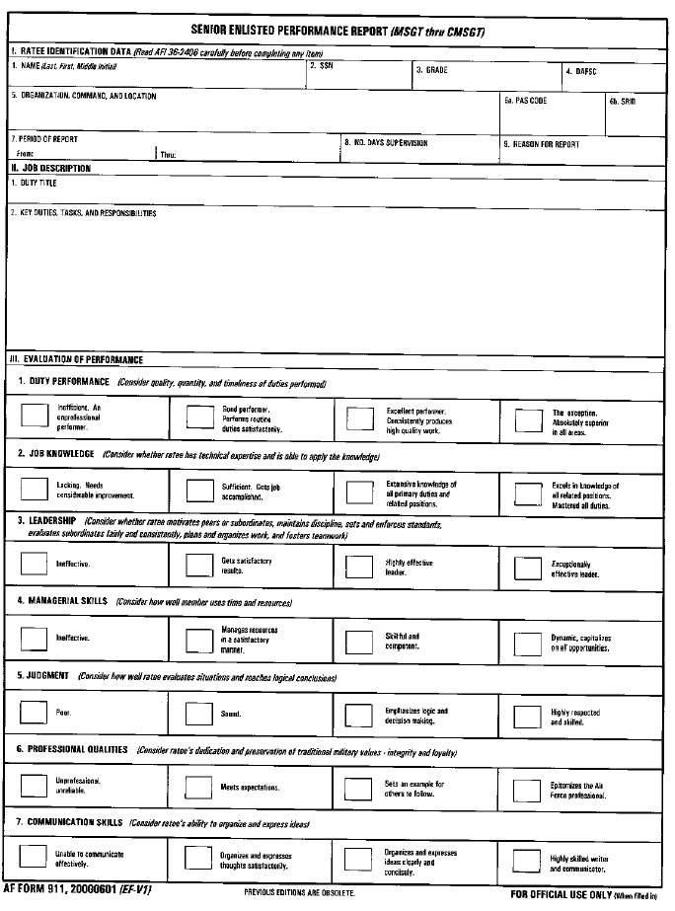
The rater uses these blocks to describe the ratee’s performance in seven key areas. Descriptions are provided with each block to give a general indication what level of performance corresponds to which block. Marking any of the blocks on the far-left side of the form will make the report a referral (see referrals).

Promotion Recommendation

The rating chain uses this area to make promotion recommendations. Compare the ratee to others in his/her grade and AFSC.

Rater's Comments

The rater uses this space to make additional comments about the ratee's performance. These comments do not have to be aligned as closely to the organization's mission. For example, a rater could discuss important achievements in special projects, additional duties, or professional organizations. Raters may also suggest selection for schools, future jobs, and promotion.

Endorser's Comments
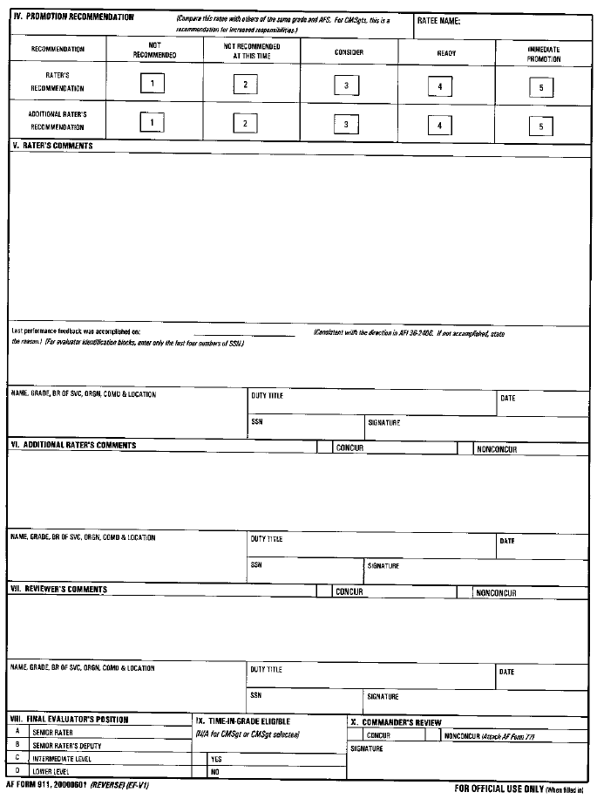
The endorser uses this section to support their rating decisions. The endorser must be the rater's rater unless endorser does not meet minimum grade requirements. Endorser may also recommend for school, future jobs and/or promotion.

Commander's Review

The squadron commander uses this section to document reviewing the report for quality, inflated ratings, and to remove any exaggerations. The commander does not provide comments (exception: if the report is a referral and the commander is named in the referral letter, or the commander disagrees with one or more ratings on a report). See AFI 36-2406, table 3.2, line 25 for more specifics.

Officer Performance Report (AF Form 707A/B)

WHAT

The Officer Performance Report (OPR) is an official record of an officer’s performance over a specified period of time. It addresses performance only! It will not include information about completion of off-duty education, PME, or promotion recommendations.

WHO

Officers in the grades of second lieutenant through colonel receive OPRs. The report’s author is the officer's rater, the person he or she works for, and from whom he or she received performance feedback. A rater is required to have a minimum of 120 days as an officer's supervisor before writing an OPR; however, this period of supervision may be shortened to 60 days if it has been more than a year since the officer's last OPR was completed. Many AFMC officers work as members of one or more Integrated Product Teams, are responsible to more than one program office, or are matrixed to another organization. This complicates the question of who rates whom. Because of this, the AFMC commander established AFMCPD 90-12 provides guidance on determining rating chains.

WHEN

OPR requirements are triggered by one of four events:

Annual (365 days) | Written 1 year after last OPR or Training Report closed out
Change of Reporting (CRO) | Written when rater changes as a result of an official PCS or PCA, if the officer is departing PCS to a school assignment, or if the officer is separating from active duty
Directed by Headquarters (DBH) | HQ USAF directs that a report be written (normally in conjunction with a selection board)
Directed by Commander | The commander can direct a report be written anytime provided there are 60 days of supervision

When one of these events occurs, the ratee's CSS office will send a notice, known as a shell, to his or her rater. The notice contains all of the personnel data needed to complete the report.

Officers who will serve in the Reserves after separating must receive an OPR. An OPR is not required if the officer is being discharged, resigning in lieu of further legal action, or if the officer is being involuntarily discharged or involuntarily released from active duty.
Ratee Identification Data
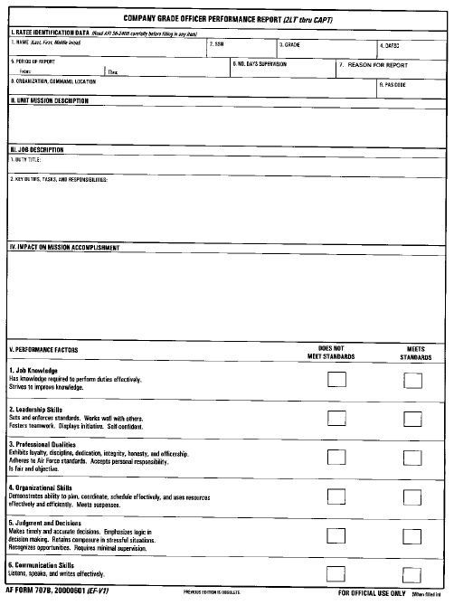
Take this information from the notice produced by your CSS office.

Unit Mission Description

This narrative describes how the unit fits into the Air Force mission. The text can be changed with the senior rater’s approval. Everyone assigned to an organization uses the same unit mission description on OPRs.

Duty Title

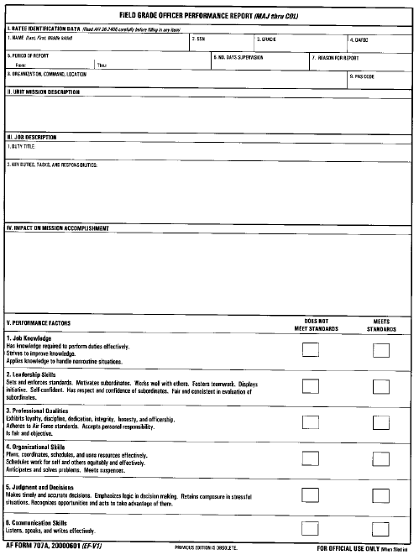
The duty title should leave no doubt what the person does. Assume the reader does not know much about the ratee’s functional area. If the ratee is serving in a SPO, it is helpful to restate the SPO’s name. "Configuration Manager for F-16 Radars" is more helpful to readers than "Configuration Manager" alone.

Job Description

This brief narrative describes how the ratee’s job fits into the unit’s mission. It can be changed by the rater without additional coordination. It should explain the ratee’s scope of responsibility and authority thoroughly and should include the number of people supervised and dollar value of assets managed.

Impact on Mission Accomplishment

Comments in this section must be in bullet format and address job performance only.

Performance Factors

This section addresses six critical performance areas and provides brief descriptions of each. Failure to meet standards in any one area would make the report a referral.
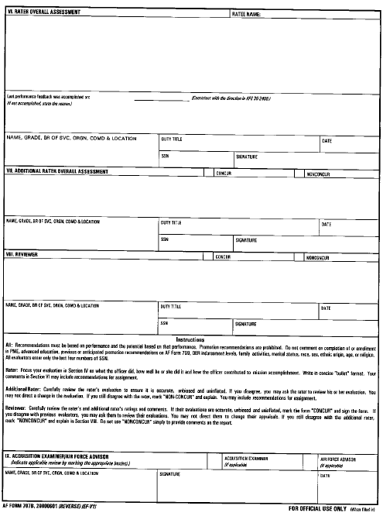
Rater Overall Assessment

The rater uses this space to make additional comments about the ratee's performance. These comments do not have to be aligned as closely to the organization's mission. For example, a rater could discuss important achievements in special projects, additional duties, or in professional organizations. Raters may also suggest selection for schools, and future jobs. (See "Deciding What to Say" for specific guidance on what type of comments should and should not appear.)

Additional Rater Overall
Assessment

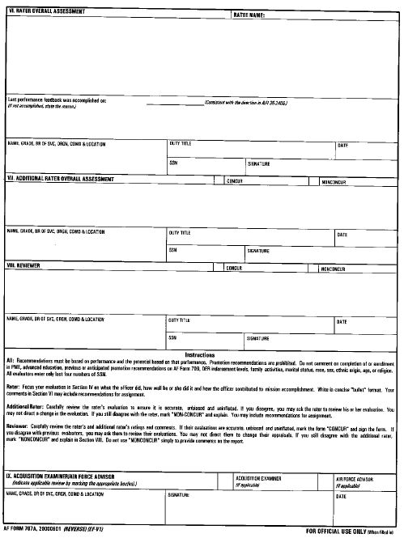
The additional rater also comments on duty performance and other relevant factors. He or she can make recommendations for future school selection and assignments. These comments are limited to a maximum of five lines.

Reviewer

The reviewer is the ratee's senior rater. (See "Reviewer" for grade requirements.) The reviewer does not make comments in the narrative block if he or she agrees with the rater and additional rater's assessments.

Acquisition Examiner Review

The Air Force requires performance reports of people serving in designated acquisition positions be reviewed by higher-ranking people who serve in the same functional specialty. In most cases, the rater, additional rater, or reviewer serves in the same functional "area" and can sign this statement. See Acquisition Reviews for more information on acquisition examiner reviews.

Referral Reports

WHAT

A referral report documents that a person did not minimally meet standards of performance, conduct, character, or integrity during a rating period. If the report leads a reader to believe the individual did not meet standards, it should be referred. The referral process gives the ratee an opportunity to comment on the negative information before it becomes a matter of record. The consequences of receiving a referral report are serious. For example, a referral EPR or an EPR with a “1” or “2” rating in the promotion recommendation block makes an NCO or airman ineligible for promotion or promotion testing until a non referral, “3” or higher, report is rendered.

WHEN

Reports must be referred if:

- A performance factor on an OPR is marked "Does Not Meet Standards"
- An officer was convicted by a courts-martial during the rating period
- There is a rating in the far left block of any performance factor in Section III, Evaluation of Performance, on an EPR, or when there is a rating of "1-not recommended for promotion" in Section IV, Promotion Recommendation, of an EPR.
- An evaluator makes comments that refer to behavior not meeting minimal acceptable standards of performance, personal conduct, character, or integrity.

Referral reports are strongly recommended when an officer was placed on the Control Roster during a rating period.

Raters must consider commenting on any Articles 15, Letters of Reprimand, Letters of Counseling, or Letters of Admonishment given to an officer during a rating period. This type of comment would clearly mandate the report being referred to the ratee.

WHO

Any evaluator in the rating chain, including the reviewer, can refer a report. A report must be
re-referred when someone in the rating chain introduces new derogatory information to the report. If this happens, the report must be returned to the ratee ("re-referred") so that he or she may comment on it.

HOW

Hand-deliver the referral memorandum and a copy of the OPR or EPR to the ratee. If the rater and ratee are geographically separated, use certified mail to send the referral memorandum and copy of report to the ratee. Ensure the ratee acknowledges receipt. The ratee may provide comments to the next evaluator in the rating chain within 10 calendar days. The ratee may also request an extension from the next evaluator if he or she wants to provide comments but is unable to do so within the 10 calendar days. If the ratee does not want to comment on the referral report, or after 10 calendar days have passed, the next evaluator in the rating chain annotates the appropriate statement as indicated below:

"I have carefully considered (ratee’s name) comments to the referral letter of (date)." or "Comments from ratee were requested but were not received within the required period."

The referral report then follows the same processing procedures as other reports.

Promotion Recommendation Forms (AF Form 709)

WHAT

This form was designed to provide central selection boards with performance-based differentiation among officers competing for promotion. It provides a brief narrative that highlights the officer's most outstanding qualifications for promotion.

WHEN

The form is finalized approximately 60 days prior to the central selection board that will consider the individual for promotion. The senior rater provides the officer a copy of the PRF approximately 30 days before the central selection board.

A narrative-only PRF (no overall recommendation in Section IX) is also completed on officers departing for in-residence professional military education schools other than Squadron Officer School, degree granting education programs (Defense Systems Management College is not in this category), or initial training in a utilization field, and for officers in long-term patient status. This form would be used if the officer became eligible for promotion while in student or patient status.

WHO

Written by a general, SES member, or senior colonel designated as an organization's "senior rater." Prepared for every officer eligible for promotion In, Above, & Below-the-Zone competing for promotion to Major, Lt Col, and Col. Promotion Recommendation Forms for promotion to Capt are only completed for officers who will receive a 'Do Not Promote this Board' or officers who have derogatory data filed in the Officer Selection Record at the Air Force Personnel Center.

HOW

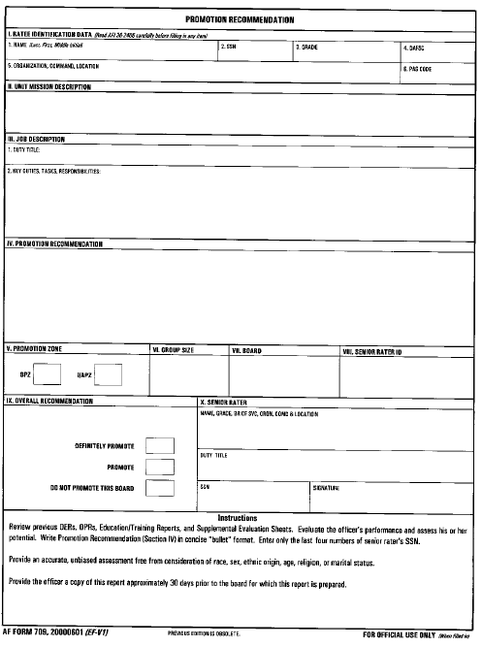
A well-written PRF covers accomplishments throughout the career, which show the officer’s depth and breadth of experience and readiness to assume the next grade. It is important to focus on performance and the impact of that performance, not just an individual’s credentials, and to emphasize how the officer stands out from peers. Comments in Section IV, Promotion Recommendation, are mandatory for all In-the-Promotion Zone and Above-the-Promotion Zone eligibles, comments are optional for Below-the-Promotion Zone eligibles who receive a “Promote” recommendation. Comments in Section IV must be in bullet format. Commanders, raters, and senior raters are required to review both the Personal Information File and Unfavorable Information File (if there is one) prior to completing a PRF. If an officer has been convicted by a court-martial, a comment on that fact must appear on that officer's next PRF for below-the-zone and in-the-zone consideration. If an officer is convicted in a court-martial after he or she has been deferred, a comment about the court-martial conviction must appear on his or her next PRF. If an officer received an Article 15, Letter of Reprimand, Counseling, or Admonishment, the commander must carefully consider commenting on those actions. The Chief of Staff strongly encourages commanders to include comments on PRFs if an officer is on the control roster.

Ratee Identification Data

Take this information from the PRF notice

Unit Mission Description

This is the same description as is used on the unit's OPRs.

Duty Title and Description

The job title states what the rate does and the description defines responsibilities and scope of authority. These can be different than the duty title and description on the officer's last OPR. (See OPRs for information on preparation.)

Promotion Recommendation

This section must be in bullet format and is limited to nine lines. It should cover the officer's entire career. Comments are optional on PRFs prepared for below-the-zone eligible officers who receive a "Promote" recommendation.

Promotion Zone

Appears on the PRF notice

Group Size

Found on the command allocation message (usually N/A).

Board

Appears on the PRF notice.

Senior Rater ID

Appears on the PRF notice.
Overall Recommendation

Determined by the senior rater. Left blank on PRFs competing for DPs at the aggregate and carry over portions of the MLR.

Senior Rater

If you are unfamiliar with the senior rater's duty title or social security account number (SSN), contact his or her secretary or executive officer.

The Process

The MLRs expose senior raters to a wide range of quality of officer records within the command. MLRs have three functions; 1) quality review, 2) Aggregation, and 3) Carry Over. The quality review ensures officers receive consideration in the promotion recommendation process and is used to correct discrepancies in the PRFs as identified by the senior raters reviewing the records of performance. The Aggregation portion of the MLR is a collection of senior raters for officers in units too small to earn a Definitely Promote (DP) allocation. Finally, the Carry Over segment is for senior raters who have more officers that warrant DP recommendation than the quota system allows. Senior raters may bring those officers’ records forward to the MLR to compete for a limited number of additional DP recommendations available. The MLR will review the records of all officers brought forward and will select the best performers.

Definitely Promote (DP) Allocations

The DP rates are based on the promotion opportunity for each grade. These rates are different for line and non-line categories and vary for each grade. The number of management level DPs are determined by applying the appropriate allocation rate to the number of IPZ or BPZ eligibles. For line officers, fractions are rounded up to the next whole number. APZ officers do not generate separate allocations. They compete for the same DP allocations generated by the IPZ population. A senior rater’s allocation is determined the same way except instead of rounding up; the allocation is rounded down. The extra portions of the fractions are added together and used at the MLR.

MLR TIMELINES

Day 150--PRF Accounting Date. Determines who will be the officer’s senior rater based on where the officer is assigned on day 150. Officer’s PCSing are still assigned to the previous senior rater until they sign in at their new duty station.

Day 90--Officer Preselection Briefs (OPB) Flow. It is the officer’s responsibility to review the OPB and work with the MPF to correct any discrepancies.

Day 60--PRF Cut-Off Date. This is the earliest date that senior rater may sign the PRFs and the master eligibility list (MEL).

Day 59--PRFs are due to AFMC/DPMQP. Please include the PRFs and the original signed MEL.

Days 60 to 40--MLRs are conducted. MLRs are held at HQ AFMC, Wright Patterson AFB OH or via Video Tel Conference (VTC).

Day 30--PRFs are due to AFPC and Officers. Members should receive their PRF approximately 30 days prior to the CSB. This allows time for the officer to bring any errors/concerns to the attention of their senior rater.

Day 28--AF Non-Line MLR. AFPC holds an MLR, in addition to the management level MLR, to award additional DP recommendations.

Day 0--Central Selection Board. All OPRs and PRFs must be in file at HQ AFPC to ensure the eligible officers receive the best opportunity for promotion.

Old Guy/New Guy Rule. Promotion recommendations provided to officers in transit between days 150 to 60 are reviewed by the gaining senior rater.

Student Status. AFPC holds an MLR to consider all eligible officers who are Air Force level students (ISS/SSS in residence). This board used the narrative-only PRFs provided by the officer’s losing senior rater along with the officer’s record of performance (ROP) to award the appropriate promotion recommendations.

MLR RESPONSIBILITIES

The Officer. Officers are responsible for ensuring data reflected on the OPB is correct. If errors exist the officer must work corrections through the appropriate office in the MPF.

The MPF. MPFs verify accuracy of senior rater ids (SRIDs) and personnel accounting symbol (PAS) codes. The MPF also provides PRF notices, MELs and Duty Qualification History Briefs (DQHBs) on each eligible to the appropriate senior rater. Other responsibilities of the MPF include providing support to the senior raters and MLRs, making the ROPS available for senior rater review, and processing narrative-only PRFs.

The Senior Rater. Senior raters must review the ratee’s ROP, DQHB, PIF, and UIF before preparing the PRF. The senior rater is solely responsible for evaluating each officer’s ROP and DQHB, and for awarding PRF recommendations among officers or submitting officers to compete for aggregation or carry-over DP recommendations.

